
Online Clothing Store

Master in Computer Application TO
RK UNIVERSITY,RAJKOT

A PROJECTREPORT
SUBMITTED IN PARTIAL FULFILLMENT OF THE REQUIREMENT FOR THE AWARD OF THE
DEGREE OF

RK UNIVERSITY,RAJKOT

SUBMITTED BY

Name of Student Enrollment No.

Sakshi Vyas 25SOECA21100
Meghana Khimaniya 25SOECA21045

UNDER THE GUIDANCE OF

Pervesh Belim Dr.NiravBhatt
Assistant Professor, Professor(HD),
RKUniversity, RK University,
RAJKOT RAJKOT

SCHOOL OF ENGINEERING, UNIVERSITY, RAJKOT



DECLARATION

We hereby certify that we are the sole authors of this project work. We also declare that neither any part of this project work, nor the entire project, has been submitted for a degree or diploma to any other University or Institution.

We further certify that, to the best of our knowledge, this project work does not infringe upon any existing copyright or violate any proprietary rights. Any ideas, techniques, quotations, or any other material from the work of others—published or otherwise—which are included in this document have been fully acknowledged and referenced in accordance with standard academic practices.

We affirm that this document is a true copy of our project work, including all final revisions, as approved by the Project Review Committee.

ProjectTeam

Sakshi Vyas(25SOECA21100)
Meghna Khimaniya(25SOECA21045)

Date:
Place: -

TABLE OF CONTENTS
TITLE | PAGE NO.
ACKNOWLEDGEMENT
ABSTRACT
1. INTRODUCTION
1.1 PROJECT SUMMARY
1.2 PURPOSE
1.3 HTML, CSS, PHP
2. PROJECT MANAGEMENT
2.1 PROJECT PLANNING AND SCHEDULING
2.1.1 PROJECT DEVELOPMENT APPROACH
2.1.2 PROJECT PLAN
2.1.3 SCHEDULE REPRESENTATION
3. SYSTEM REQUIREMENTS STUDY
3.1 USER CHARACTERISTICS
3.2 HARDWARE
4. SYSTEM ANALYSIS
4.1 STUDY OF CURRENT SYSTEM
4.2 PROBLEM & WEAKNESS OF CURRENT SYSTEM
4.3 FEASIBILITY STUDY
4.4 REQUIREMENT VALIDATION
4.5 FUNCTION SYSTEM
4.5.1 E-R DIAGRAM
4.5.2 USE CASE DIAGRAM
4.5.3DATA FLOW DIAGRAM
4.6 DATA MODELING
4.7 MAIN MODULES OF NEW SYSTEM
5. SYSTEM DESIGN
5.1 FLOW CHART
6. TESTING
6.1 TEST PLAN
6.2 TESTING STRATEGY
6.2 TESTING STRATEGY
6.3 TESTING METHODS
6.4 TESTING CASES
7. SCREEN SHOTS
8. LIMITATION & FUTURE ENHANCEMENT
9. CONCLUSION AND DISCUSSION
10. REFERENCES

DECLARATION
[Write your declaration here]

INDUSTRY CERTIFICATE
[Attach scanned certificate here]

COLLEGE CERTIFICATE
[Insert college certificate format]

ACKNOWLEDGEMENT

The success and final outcome of this project required a lot of guidance and assistance from many people and We are extremely fortunate to have got this all along the completion of my project work. Whatever we have done is only due to such guidance and assistance and we would not forget to thank them.
We respect and thank RK University for giving us an opportunity to do the project work in 1MCA and providing us all support and guidance which make us complete the project on time. We are extremely grateful to him for providing such a nice support and guidance though he had busy schedule managing the company affairs.
We also thank our internal project guide, Prof. Pervesh Belim, RK University Rajkot, for his guidance and suggestions during this project work.
We are thankful to and fortunate enough to get constant encouragement, support and guidance from all Teaching staffs of Department of Master of Computer Application which helped us in successfully completing our project work. Also, we would like to extend our sincere regards to all the non-teaching staff of department for their timely support.

ABSTRACT
[Write your abstract here]

The Online Clothing Store Website is a web-based application developed using PHP and MySQL to provide users with a convenient and efficient platform for purchasing apparel from anywhere at any time. The system allows customers to browse products by category, view detailed descriptions, manage shopping carts, and place secure orders. It enhances the traditional shopping experience by offering quick search, user authentication, and easy navigation through a responsive interface.
For administrators, the system simplifies store management by providing modules to manage inventory, update product details, monitor stock availability, and handle customer orders in real time. By adopting a centralized approach, the platform improves business operations, reduces manual effort, and supports future scalability. This project aims to deliver a reliable, user-friendly, and cost-effective e-commerce solution tailored for the clothing retail industry.

ABBREVIATIONS
[Add abbreviation list]
Abbreviation | Full Form
PHP | Hypertext Preprocessor
MySQL | Structured Query Language (Database System)
CSS | Cascading Style Sheets
HTML | HyperText Markup Language
UI | User Interface
UX | User Experience
OTP | One-Time Password
CRUD | Create, Read, Update, Delete
ID | Identification
DBMS | Database Management System
URL | Uniform Resource Locator

NOTATIONS
Notation | Description
P | Price of the product
Q | Quantity selected by the user
→ | Data flow direction in Data Flow Diagrams
N | Total number of registered users
PID | Product Identifier (Primary Key)
CID | Customer Identifier (Primary Key)
₹ | Currency representation (Indian Rupee
SQL Query (SELECT, INSERT, UPDATE, DELETE) | Database operations
Status = 0/1 | Order/Payment state (0 = Pending, 1 = Completed)
S | Size of Clothing Item (S, M, L, XL)

CHAPTER 1 – INTRODUCTION

- Introduction
The Online Clothing Store Website is a web-based platform developed using PHP and MySQL that enables customers to explore, search, and purchase a wide range of apparel from the comfort of their homes. This system ensures a seamless shopping experience with features such as product browsing, category-based filtering, secure user authentication, and an easy checkout process

1.1 Project Summary – Key to a good summary is the FIRST sentence, which MUST
This project develops a PHP-based cloth Store Website that allows customers to explore various clothing categories, add products to a cart, and place online orders while enabling the admin to manage inventory and sales through a secure backend panel. The system aims to digitize the traditional cloth-shopping process by providing an accessible, user-friendly, and automated e-commerce solution.

1.2 Purpose : Goals & Objectives
Purpose
The purpose of the system is to create an online cloth-selling platform that simplifies purchasing for users and enhances product management for administrators.
Goals
- To develop a fully functional online cloth store using PHP.
- To create an interactive interface for product browsing and ordering.
- To provide a secure admin dashboard for inventory and order management.
- To reduce manual work for store owners by automating sales processes.
Objectives
- Implement a product catalog with categories, filters, and search.
- Enable cart, checkout, and order placement functionality.
- Provide admin functionalities for CRUD operations (Create, Read, Update, Delete).
- Maintain a responsive and user-friendly UI.

1.3 Scope (Scope – what it can do and can’t do)
In-Scope (What the System CAN Do)
- Display product with images, price, description.
- User registration and login.
- Add to cart, update cart, checkout.
- Online order placement.
- Admin login and product management.
- Manage stock, categories, and customer details.
Out-of-Scope (What the System CANNOT Do)
- Real-time delivery tracking.
- Analytics dashboards for sales forecasting.
- Customer support live chat system.
- Multi-language support.
- Return or refund management.
- Product comparison feature.

1.4 Technology and Literature Review of Past Work/System
Technologies Used
- Frontend: HTML5, CSS3, Bootstrap, JavaScript
- Backend: PHP (Core PHP)
- Database: MySQL
- Web Server: Apache (XAMPP/WAMP)
- Tools/IDE: VS Code, phpMyAdmin
Literature Review / Past Systems
Earlier physical cloth shops relied on manual processes causing delays and inaccuracies. Some local store websites lacked:
- User login & personalized cart
- Organized product management
- Secure admin dashboards
Modern e-commerce sites (like Myntra, Ajio, Amazon cloths) influenced this project’s design to offer:
- Efficient browsing
- Cart-based shopping
- Admin-driven product management
The cloth Store Website adopts these modern practices in a simplified PHP application.

CHAPTER 2 – PROJECT MANAGEMENT

2.1Project Planning and scheduling

2.1.1 Project Development Approach (Process Paradigm) and Justification
Justification
- The project requirements for the cloth Shopping System were clear, fixed, and well-defined from the beginning.
- The system needed proper step-by-step documentation, which aligns well with the Waterfall approach.
- The project mainly involves PHP-based CRUD operations (product management, cart, orders), which suit a sequential development flow.
- Each stage of development (UI design, backend coding, testing) could be completed one after another without overlap.
- Progress was easy to track because the project moved through structured milestones such as design → coding → testing → deployment.
- Phases
- Requirement Analysis
- System Design
- Coding in PHP
- Testing (Unit & Integration)
- Deployment
- Maintenance

2.1.2 Project Plan including Milestones, Deliverables, Roles, Responsibilities and Dependencies
Milestones
- Requirements collected and finalized
- System design prepared
- Core modules developed (Admin, User, Cart, Orders)
- System tested and issues resolved
- Final deployment completed
Deliverables
- Completed SRS document
- ER diagram, DFDs, and UI screen designs
- Fully coded PHP/MySQL modules
- Test reports and bug fixes
- Working cloth Shopping System
Roles & Responsibilities
- Developer: Builds system functionality, integrates backend and database
- Designer: Creates page layouts, UI styling, and interface components
- Database Admin: Structures database tables, relationships, and data consistency
- Tester: Validates features, identifies bugs, and ensures quality
Dependencies
- Local server setup (XAMPP/WAMP)
- Stable MySQL database
- Internet access for frameworks and libraries
- Product data (images, descriptions, prices)

2.1.3 Schedule Representation
Planned Schedule Overview
- Phase 1: Requirement Analysis
Identifying system needs, defining features, preparing SRS.
- Phase 2: System Design
Creating architecture, database design, and interface layouts.
- Phase 3: Development
Building all modules (User, Admin, Cart, Orders) and integrating MySQL.
- Phase 4: Testing
Checking functionality, correcting errors, validating performance.
- Phase 5: Deployment
Running the system on local server and finalizing the project.

Flow Representation
Requirement Analysis → Design → Development → Testing → Deployment

Short Duration Summary
- Requirement Phase – Initial stage
- Design Phase – After requirements
- Development Phase – Main coding work
- Testing Phase – After coding
- Deployment Phase – Final step

2.2 Risk Management
2.2.1 Risk Identification (it is concerned with discovering possible risk to
the project)
1. Technical Risks
- Server failure or local environment issues (XAMPP/WAMP not working).
- Database connection errors due to incorrect configuration.
- Code integration issues between different modules (Admin, User, Cart).
- Browser compatibility problems affecting UI display.
2. Operational Risks
- Insufficient or unclear product data (missing cloth images, wrong price, incomplete descriptions).
- Incorrect database design leading to performance issues.
- Delays in development due to bug fixes or rework.
3. Security Risks
- Unauthorized access if login validation is weak.
- SQL injection or data breaches due to improper sanitization.
- Weak password handling causing account vulnerability.
4. Resource Risks
- Laptop/PC failure leading to project delays.
- Lack of stable internet required for libraries or testing.
5. Project Management Risks
- Scope creep (adding extra features not originally planned).
- Schedule overruns if milestones are not followed.
- Incomplete documentation affecting future maintenance.

2.2.2 Risk Analysis(each identified risk is considered in turn and a judgment
made about the probability and the seriousness of the risk)

Identified Risk | Probability | Seriousness (Impact)
XAMPP/WAMP server failure | Medium | High
Database connection errors | High | High
Missing or unclear product images/data | Medium | Medium
UI not working properly on some browsers | Low | Medium
Weak login validation | Medium | High
Development delays due to bugs | Medium | Medium
Laptop/PC hardware failure | Low | High
Internet issues while downloading libraries | Medium | Low
adding extra features | Medium | Medium
Incomplete or missing documentation | Low | Medium

2.2.3 Risk Planning (Identify strategies to manage the risk)
Note: Discuss the risks associated with your project or system only. Do not
write theory of risk management.
The following plans have been prepared to manage the risks identified in the cloth Shopping System:
1. Server / Environment Failure
- Keep backup installation of XAMPP/WAMP.
- Regularly check Apache and MySQL services to avoid unexpected downtime.
2. Database Connectivity Problems
- Test database connectivity during initial setup.
- Maintain correct configuration files and enable error logging for quick detection.
3. Incomplete Product Data
- Gather all product images, prices, and descriptions before uploading.
- Maintain a verified dataset to avoid incorrect or missing information.
4. UI and Browser Compatibility Issues
- Test the interface on multiple browsers.
- Use a responsive framework to ensure consistent layout.
5. Security Risks (SQL Injection, Weak Authentication)
- Use prepared statements and input validation.
- Implement strong password rules and secure login handling.
6. Development Delays / Bug Issues
- Conduct continuous testing after each module completion.
- Allocate buffer time for resolving issues.
7. Hardware / System Failure
- Take regular backups of the project folder and database.
- Store backups on external or cloud storage.
8. Internet Dependency
- Download all required libraries and dependencies offline.
- Maintain a local backup of Bootstrap, jQuery, icons, etc.
9. Scope Creep
- Follow finalized project requirements strictly.
- Avoid adding new features beyond the approved scope.
10. Single Developer Workload
- Divide the project into smaller tasks.
- Maintain weekly progress tracking to ensure timely completion.
11. Documentation Issues
- Update documentation at the end of each development phase.
- Maintain organized folders for design, development, and testing documents.

CHAPTER 3 – SYSTEM REQUIREMENTS STUDY

3.1 USER CHARACTERISTICS
The Online cloth Store System will be used by two types of users:

1. Customers
- Basic computer and mobile usage knowledge
- Should be able to browse products
- Should understand simple user interfaces
- No technical expertise required

2. Admin
- Basic understanding of website dashboard
- Able to manage product listings (add/update/delete)
- Should know how to view orders, customers, and stock
- Responsible for updating product data and maintaining records
These user types ensure smooth use of the system from both front-end (customer) and back-end (admin) perspectives.

3.2 HARDWARE AND SOFTWARE REQUIREMENTS

1.Hardware Requirements

Component | Minimum Requirement
Processor | Dual Core or higher
RAM | 2 GB (4 GB recommended)
Storage | 10 GB free disk space
Display | 1024 × 768 resolution
Internet | Broadband connection

2.Software Requirements

Software | Requirement
Operating System | Windows 10/11, Linux
Server | XAMPP (MySQL, PHP)
Database | MySQL 5.7 or above
Browser | Chrome / Firefox / Edge
Editor | VS Code
Programming Languages | HTML5, CSS3, Bootstrap, JavaScript, PHP
These specifications ensure that the system runs efficiently on both development and deployment environments.

3.3 CONSTRAINTS
The Online cloth Store System operates under the following constraints:

1. Regulatory Policies
- User data must be stored securely.
- Passwords must be encrypted following privacy standards.

2. Hardware Limitations
- System performance may vary on low-processor or low-RAM devices.
- High-resolution images may load slowly on older systems.

3. Interfaces to Other Applications
- Requires browser support for HTML, CSS, JavaScript.
- Depends on MySQL database connectivity through PHP.

4. Parallel Operations
- Multiple users accessing the system simultaneously may cause slight delays.
- Admin actions are restricted when database updates occur.

5. Higher Order Language Requirements
- System entirely depends on PHP server-side execution.
- Requires JavaScript for dynamic front-end operations.

6. Reliability Requirements
- Database must be stable and connected at all times.
- Online store must remain available 24×7 to users.

7. Criticality of the Application
- Incorrect price or stock data can affect sales.
- Any downtime directly impacts the user experience and sales.

8. Safety & Security Considerations
- User credentials must be stored in hashed format.
- SQL injection, unauthorized access, and session hijacking must be prevented.
- Secure admin login is necessary.

9. Assumptions & Dependencies
- Users have stable internet connectivity.
- Admin regularly updates product entries.
- Server (Apache/MySQL) remains active during usage.
- System depends on availability of browser and PHP runtime.

4.1 STUDY OF CURRENT SYSTEM
The System Study is a critical component of the project lifecycle, aimed at understanding the existing environment, identifying challenges, and assessing the scope and feasibility of the proposed system. In this case, the Online Clothing Store project was planned after a detailed study of the traditional clothing retail business, its limitations, and the potential improvements that an online platform could offer.
The System Study forms the foundation of the software development process. It involves understanding the problem domain, identifying user needs, and analyzing how a new system can fulfill those needs effectively. For this project, the system study helps in identifying the issues faced by both customers and store owners in the traditional apparel shopping process.

4.2 PROBLEM & WEAKNESS OF CURRENT SYSTEM

Traditional cloth retail systems, which depend heavily on physical infrastructure and manual processes, come with various limitations:
1. Limited Size Availability: Not all cloth sizes may be available, leading to customer frustration.
2. Inaccurate Product Images/Descriptions: Misleading photos or incomplete descriptions can cause returns.
3. Return/Exchange Issues: Complicated return policies can frustrate customers.
4. Fake Reviews or Ratings: Misleading reviews reduce customer trust.
5. Ineffective Search & Filters: Hard for customers to find the right cloth quickly.
6. Inventory Mismatch: Product may show as available online but is out of stock in reality

4.3 FEASIBILITY STUDY

The feasibility study is essential in evaluating whether the proposed system is practical, sustainable, and worth implementing. The Online cloth Store project was evaluated on the following feasibility factors:

A. Technical Feasibility
- The system uses PHP, MySQL, JavaScript, and Bootstrap — all of which are widely supported and open-source technologies.
- Hosting is compatible with most standard Linux-based servers.
- Basic system requirements for the customer include only a browser and internet connection.

B. Operational Feasibility
- The system is easy to use and requires minimal training for both customers and admins.
- Customer workflows (like login, shopping, and checkout) are intuitive.
- Admin interfaces allow straightforward management of products, users, and transactions

C. Economic Feasibility
- Development costs are low due to the use of open-source technologies.
- No need for physical infrastructure reduces initial capital investment.
- Long-term maintenance is affordable and scalable.

D. Legal and Ethical Feasibility
- Secure login and encrypted data handling ensure user privacy.
- Terms and conditions, as well as privacy policies, are clearly defined for legal compliance.

4.4 REQUIREMENT VALIDATION

1. Functional Requirements
Functional requirements define the core features and operations of the system. These are the functionalities that the system must perform:
1. User Registration & Login:
- Customers must be able to create an account with personal information like name, email, address, and password.
- The system should verify credentials during login and manage user sessions securely.
2. Product Browsing:
- Users can view product listings categorized by type (men, women, kids featured, etc.).
- Each product page will display the image, description, price, size, and availability
3. Shopping Cart Management:
- Customers can add, remove, or update quantities of products in their cart.
- The cart should persist across sessions until checkout.
4. Order Placement & Confirmation:
- Customers can proceed to checkout, confirm shipping details, and complete payment.
- The system will generate an order confirmation and unique order ID.
5. Admin Product Management:
- Admins can add, update, and delete products from the inventory.
- Admins can mark products as “featured” or categorize them
6. Search and Filter:
- Users can search for products by name, price range, or size.
- Filters should dynamically adjust the product list
7. Logout Functionality:
- Users and admins must be able to log out securely

2. Non-Functional Requirements
These are performance-related specifications that define how well the system performs:
1. Usability:
- The interface must be simple and intuitive for non-technical users.
- Navigation should be responsive and user-friendly.
2. Security:
- User passwords should be stored securely (hashed and encrypted)
- Data protection measures must be in place for transactions and personal information.
2. Performance:
- Pages should load in under 2 seconds on average.
- The system should support multiple users simultaneously (scalability).
3. Availability:
- The system should be available 99.9% of the time, with minimal downtime.
4. Maintainability:
- Code should be well-documented and modular for easy updates and debugging.
5. Portability:
- The system should run on major web browsers (Chrome, Firefox, Edge).
- Mobile responsiveness should be maintained via Bootstrap

3. User Requirements
This section defines what different types of users expect from the system:

Customers:
Create and manage their account.
Browse and purchase products easily.
Receive order confirmations and shipping updates.
Access help/contact pages.
Administrators:
Login to an admin dashboard.
Manage product listings and update inventory.
View customer orders and sales reports.
Maintain user accounts and handle customer queries
CHAPTER 5 – SYSTEM DESIGN
System design focuses on transforming the user requirements and system specifications into a structured solution. It involves the representation of the system architecture, interface, data flow, and database structure to ensure smooth development and implementation.

5.1 System Architecture Design
The system follows a Three-Tier Architecture:
1️ Presentation Layer – User Interface (Customers & Admin)
2️ Business Logic Layer – Handles login, cart, orders, product request processing
3️ Data Layer – MySQL Database for storing all records
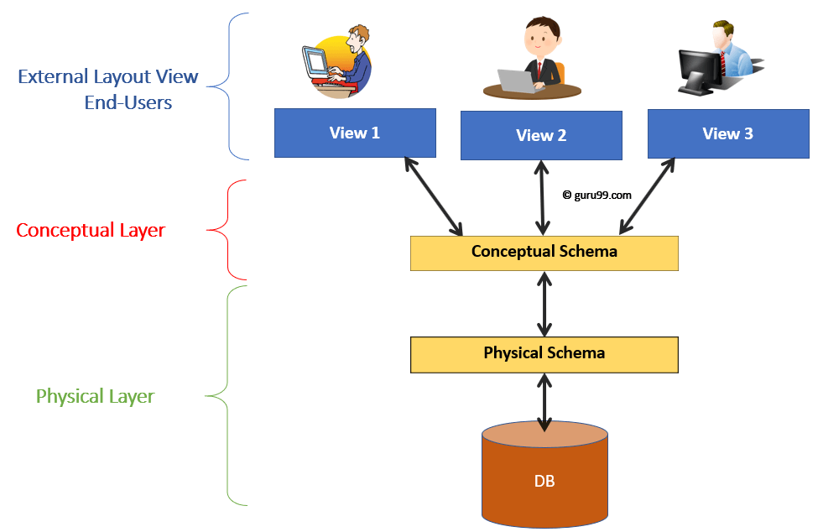

5.2 Use Case Diagram
- Online Clothing Purchase System
Admin
Registered User
Guest User
Add product
Delete product
Update product detail
View product
Search product
Filter product
Post review
View product detail
Add product to Wishlist

5.3 DFD (Data Flow Diagram)
- 0 Level DFD

Customer Management

Product Management
Category Management

Online Clothing Store

Sales Management
System User Management

Login Management

5.4 DFD (Data Flow Diagram)
- 1 Level DFD
Customer Management
Generate Customer Report

Product Management
Generate Product Report

Payment Management
Gererate Payment Report
Online Clothing Store

Order Management
Generate Order Report

Login Management
Check User Login Details

System User Management
Generate System User Report

5.5 ER Diagram

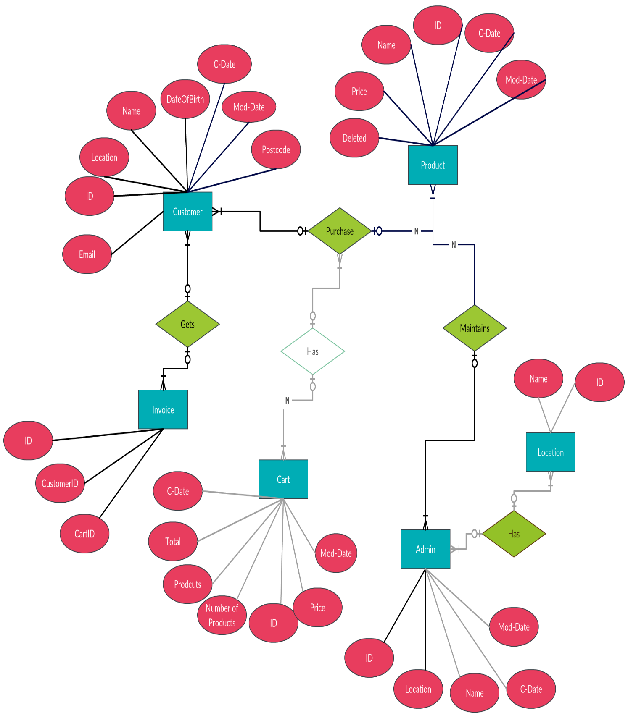

CHAPTER 6 – IMPLEMENTATION
6.1 Implementation Environment (Single vs Multiuser, GUI vs Non GUI)
Single-User vs Multi-User Environment
- Multi-User Environment (Used)
  - The cloth Store System is web-based and can be accessed by multiple users (Admin, Staff, Customer).
  - All users interact with a centralized MySQL database hosted on a server.
- Single-User Environment (Possible)
  - The system can also run locally on XAMPP for development or testing.
  - Only one user (Admin) interacts with the system in local mode.
GUI vs Non-GUI
- GUI (Used)
  - The platform uses HTML, CSS, JavaScript for front-end.
  - PHP (backend) generates dynamic web pages.
  - Attractive, user-friendly interface for product management, orders, and customer handling.
- Non-GUI (Not Used)
  - No command-line interaction.
  - Not suitable for store staff/customers.

6.2 Program/Modules Specification
Main Modules of the cloth Store Management System
1. Admin Login Module
- Secure login using username & password
- Redirects to admin dashboard
2. Product Management Module
- Add, update or delete cloth products
- Manage product categories (Men, Women, Kids, Casual, etc.)
- Upload images for cloths
- Control stock quantity, price, sizes
3. Customer Management Module
- View list of all registered customers
- Search customer by name, phone, or email
4. Order Management Module
- Create new orders
- Add cloths to cart
- Apply discount/coupon
- Generate bill
- Update stock automatically
5. Coupon / Offer Management
- Create promotional codes
- Set discount percentage/value
- Set validity date

6.3 Security Features
Authentication & Session Security
- Secure admin and user login using hashed passwords.
- Session-based access control to prevent unauthorized entry into admin pages.
Input Validation
- Validation on all forms (registration, login, product upload, coupon creation) to avoid empty or invalid data.
Data Integrity Measures
- Stock quantity updated only after a confirmed order.
- Coupon validation prevents unauthorized use.

6.4 Coding Standards
1. Coding Style
- PHP code written using proper indentation (4 spaces).
- Clear separation of PHP, HTML, CSS, and JavaScript.
- Consistent use of lowercase filenames (e.g., add_ product.php, manage category.php).
2. Naming Conventions
- Variables: camelCase (e.g., $productName, $totalPrice).
- Functions: camelCase (e.g., addProduct(), updateCategory()).
- Database tables: lowercase_with_underscore (e.g., products, categories, orders).
3. File Organization
- Separate folders for:
  - admin/ – admin pages
  - user/ – customer pages
  - includes/ – header, footer, menu
  - config/ – database connection
  - uploads/ – product images
4. Reusability
- Common layouts stored in reusable include files (header.php, footer.php).
- Reusable functions written in a separate file (functions.php).
5. Commenting Standards
- Each module includes header comments describing purpose.
- Inline comments used to explain complex logic.
- HTML & CSS Standards
- Follows responsive layout using Bootstrap.
- Proper use of class names and IDs.

CHAPTER 7 – TESTING

What is testing?
Testing is the process of evaluating and verifying that a software product or application.
7.1 TESTING PLAN

The testing plan ensures that the cloths Store Website works correctly, meets functional requirements, and provides a smooth user experience. Testing is done on Visual Studio 2022 using localhost/phpMyAdmin for database operations.
Objectives:
- Verify all user and admin functionalities.
- Identify and fix defects before deployment.
- Ensure secure operations (password, payment, email).
Scope:
- User modules: login, registration, cart, wishlist, payment, profile, review, change/forgot password.
- Admin modules: manage products/categories/orders, generate report (if implemented).
Tools:
- VS Code 2022
- Browser (Chrome)
- phpMyAdmin (127.0.0.1)
- PHPMailer (SMTP) for email functionality

7.2 TESTING STRATEGY

- Black Box Testing
  - A form of testing that is performed with no knowledge of a system’s internals.
- White Box Testing
  - It is a software testing technique that involves testing the internal structure and working of a software application.
- Gray Box Testing
  - In Gray Box Testing, the tester designs test cases using partial knowledge of the internal system.

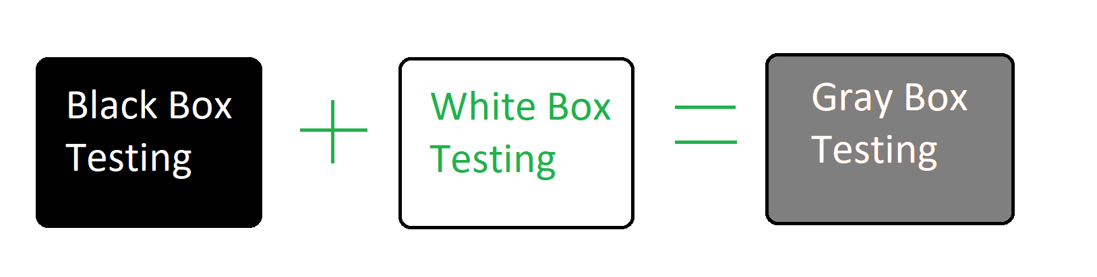
7.3 TESTING METHOD
Type of testing:
- Manual Testing
  - Testing is performed manually without using tools.
- Automation Testing
  - Automation Testing is a software testing technique where testing is performed using automated tools or scripts instead of manually executing test cases. It helps to save time, increase accuracy, and run repeated test cases automatically.

7.4 TEST CASE
Test Objective: Login

Test case id | Test step | Input data | Expected result | Actual result | Execution status
1 | To check  Enter valid  UserName,  password | Enter valid  UserName,  password | Admin goes to the dashboard | Admin login successfully | Login successful
2 | To check UserName, password | Enter invalid UserName, password. | Admin should not go on dashboard | Admin login failed | Login unsuccessful

Test Objective: Registration

Test case id | Test step | Input data |  | Expected result |  | Actual result |  | Execution status
1 | To check entering Full Name, Email, Password, Confirm Password, Mobile Number and Address | Enter all fields with valid data and matching password & confirm password |  | All fields should accept data and show no validation errors |  | Works as expected |  | Successfully executed
2 | To click on Registration button |  | Fill all fields with proper valid data and click Register |  | User record should be stored in database and redirect to Login page |  | Record stored and redirected successfully |  | Successfully executed
3 | Check email verification link |  | Click the verification link sent to the registered email |  | Account should be verified and redirected to Login page |  | Registration successfully  redirected login page |  | Successfully executed
4 | Invalid or expired verification link |  | Click an expired or incorrect verification link |  | System should display “Verification link is invalid or expired” |  | Registration unsuccessfully |  | Successfully executed

Test Objective: Feedback

Test case id | Test step | Input data | Expected result | Actual result | Execution status
1 | To click on the Submit button | Fill all fields with proper data in the form | Record should be stored in the database successfully | Record submitted successfully | Successfully executed

Test Objective: Category

Test case id | Test step | Input data | Expected result | Actual result | Execution status
1 | Click on Add button | Fill all fields with valid data in the form | The record should be inserted into the database | Record inserted successfully | Successful.
2 | Click on Delete button | Enter a valid name in the form to delete the record | The selected record should be deleted from the database | Record deleted successfully | Successful
3 | Click on Search button | Enter a valid keyword or category name | The system should display matching category records | Records displayed correctly | Successful

Test Objective: Product

Test case id | Test step | Input data | Expected result | Actual result | Execution status
1 | To click on Submit button. | button  Fill all fields with valid product data | The product record should be inserted into the database | Product inserted successfully | Successful
2 | Click on Edit button | Modify all product fields with valid data | The updated product record should be saved in the database | Product updated successfully | Successful
3 | Click on Delete button | Enter a valid Product ID to delete | The selected product should be deleted from the database | Product deleted successfully | Successful
4 | Click on Search button | Enter product name | The system should display matching product records | Matching records displayed successfully | Successful

Test Objective: Brand

Test case id | Test step | Input data | Expected result | Actual result | Execution status
1 | Click on Add button | Fill all fields with valid data in the form | The record should be inserted into the database | Record inserted successfully | Successful.
2 | Click on Delete button | Enter a valid name in the form to delete the record | The selected record should be deleted from the database | Record deleted successfully | Successful
3 | Click on Search button | Enter a valid keyword or category name | The system should display matching category records | Records displayed correctly | Successful

CHAPTER 8 – SCREENSHOTS & USER MANUAL
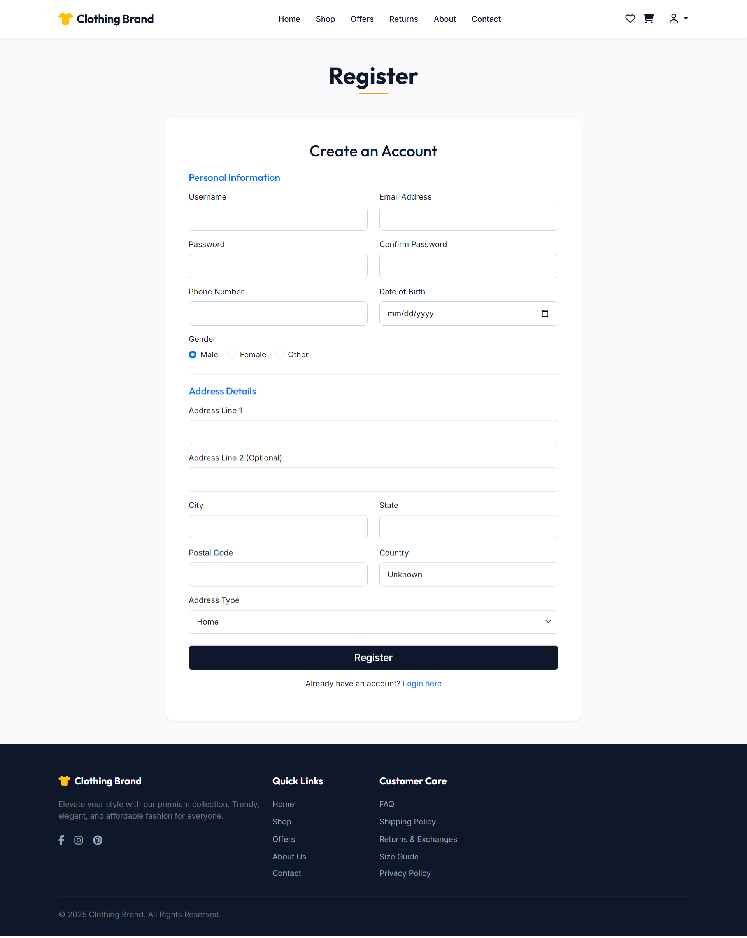
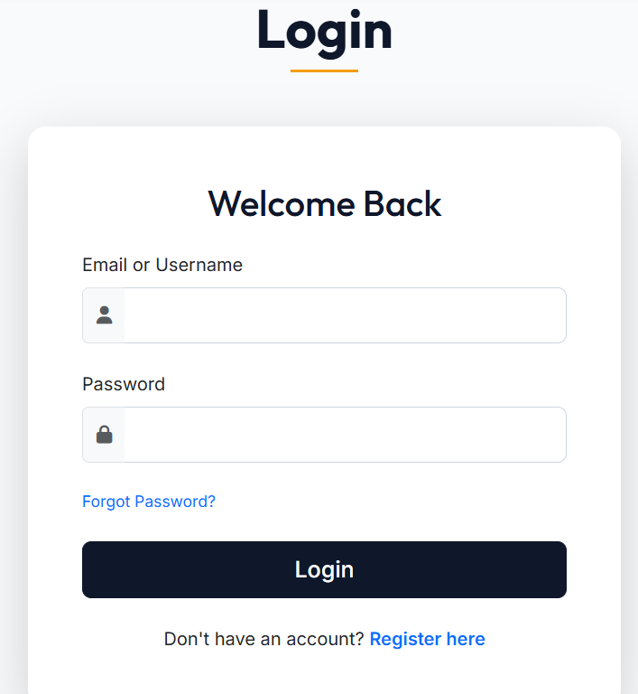
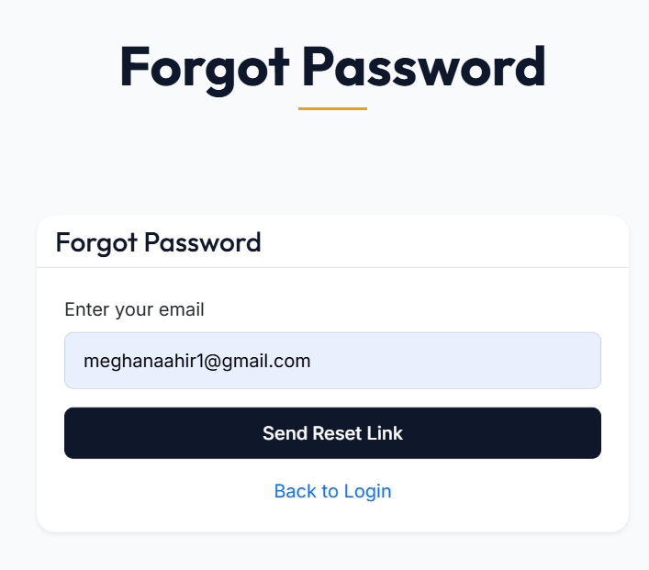
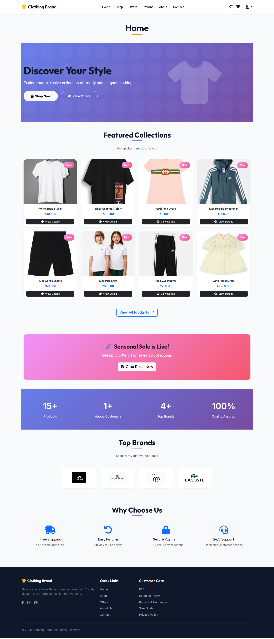
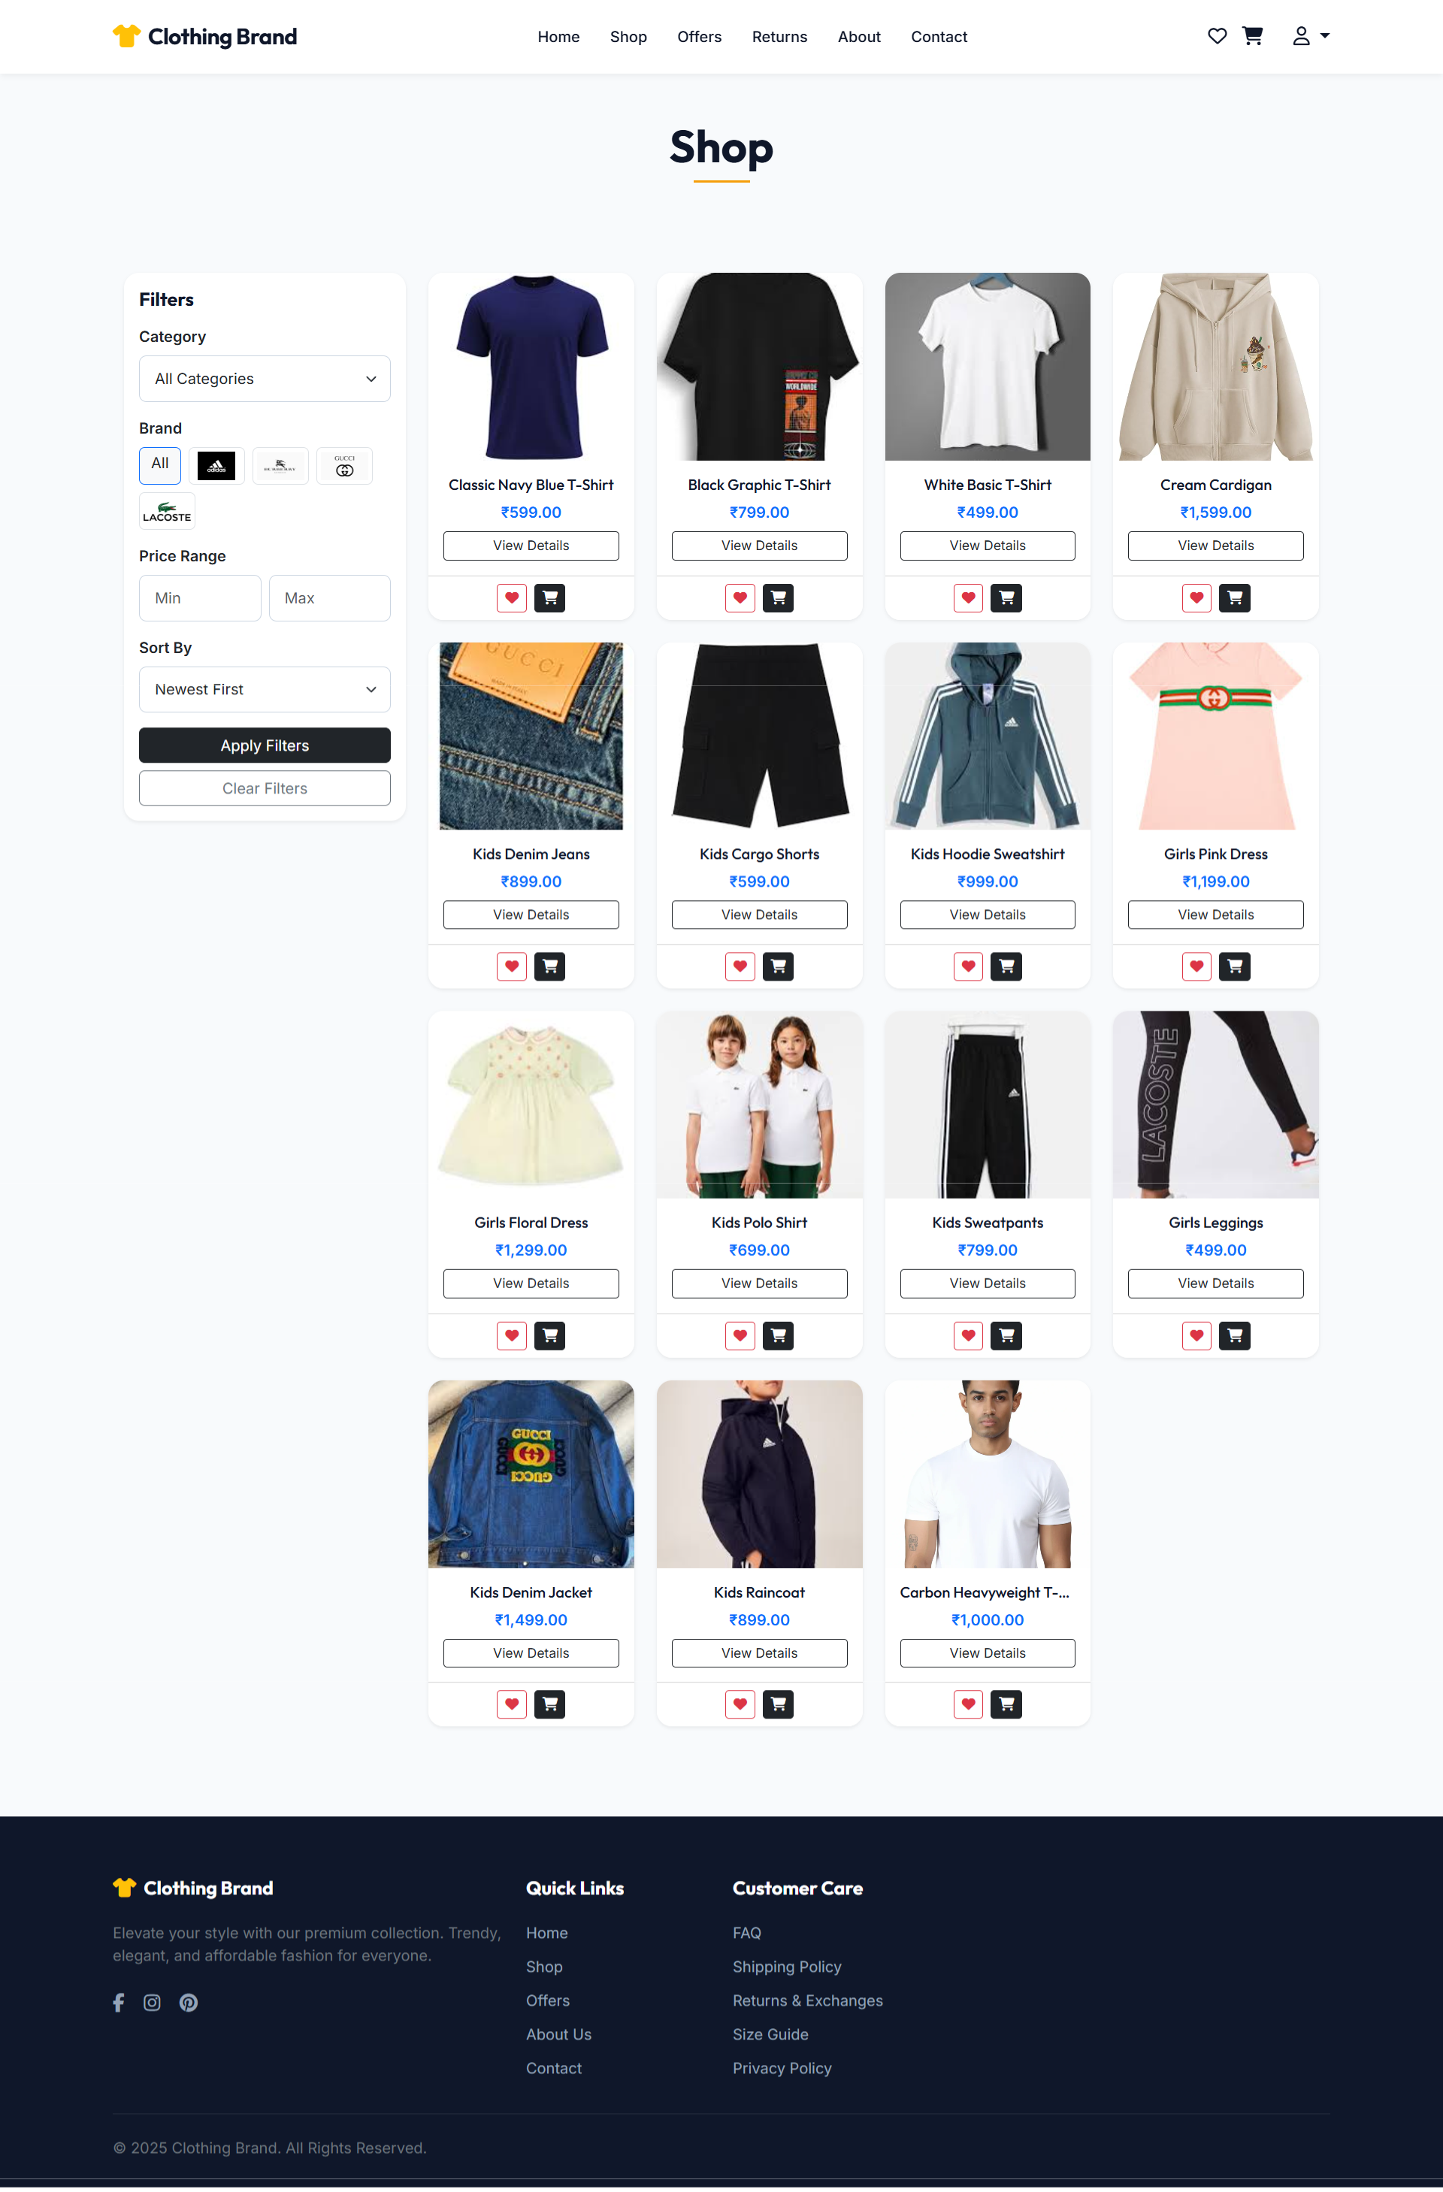
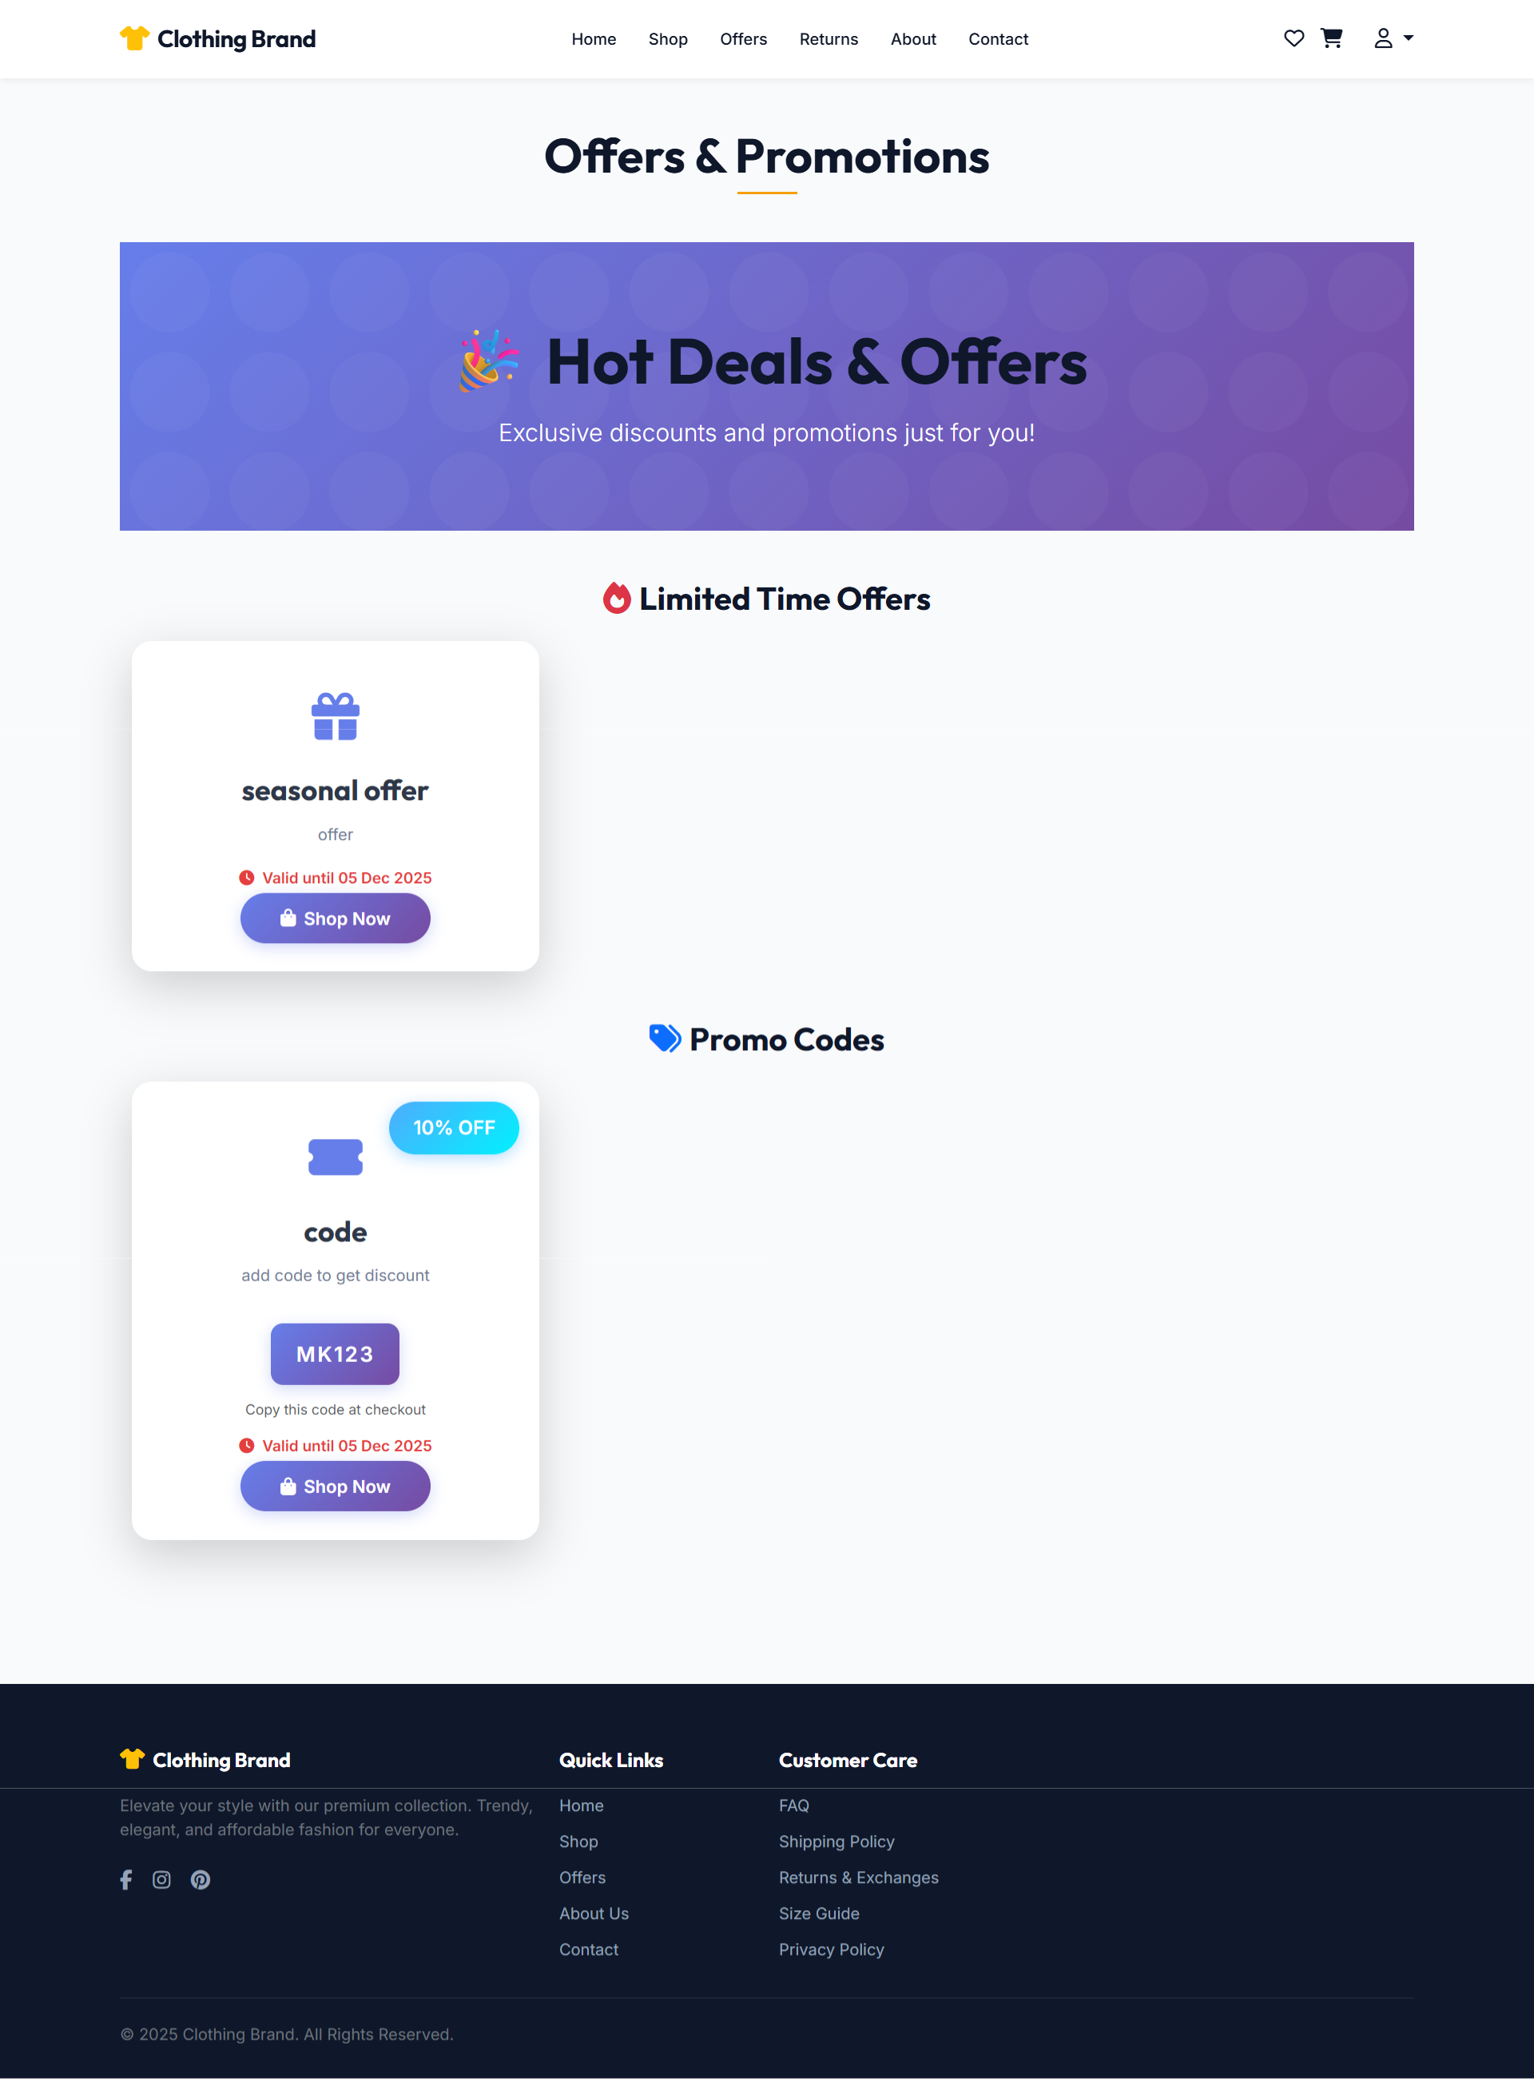
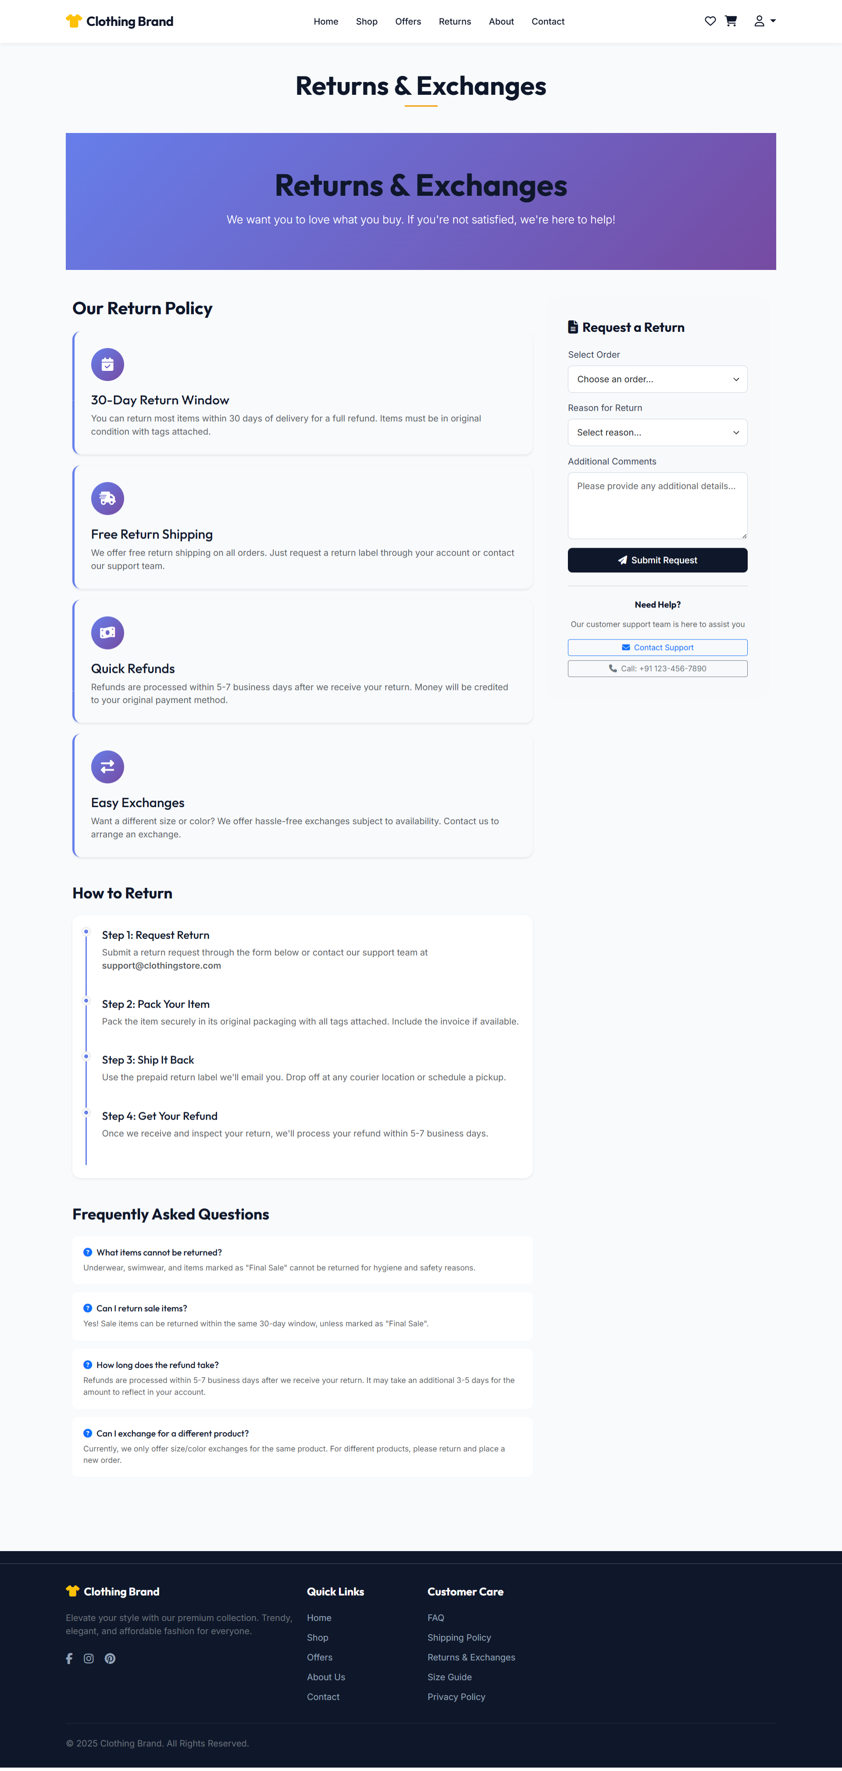
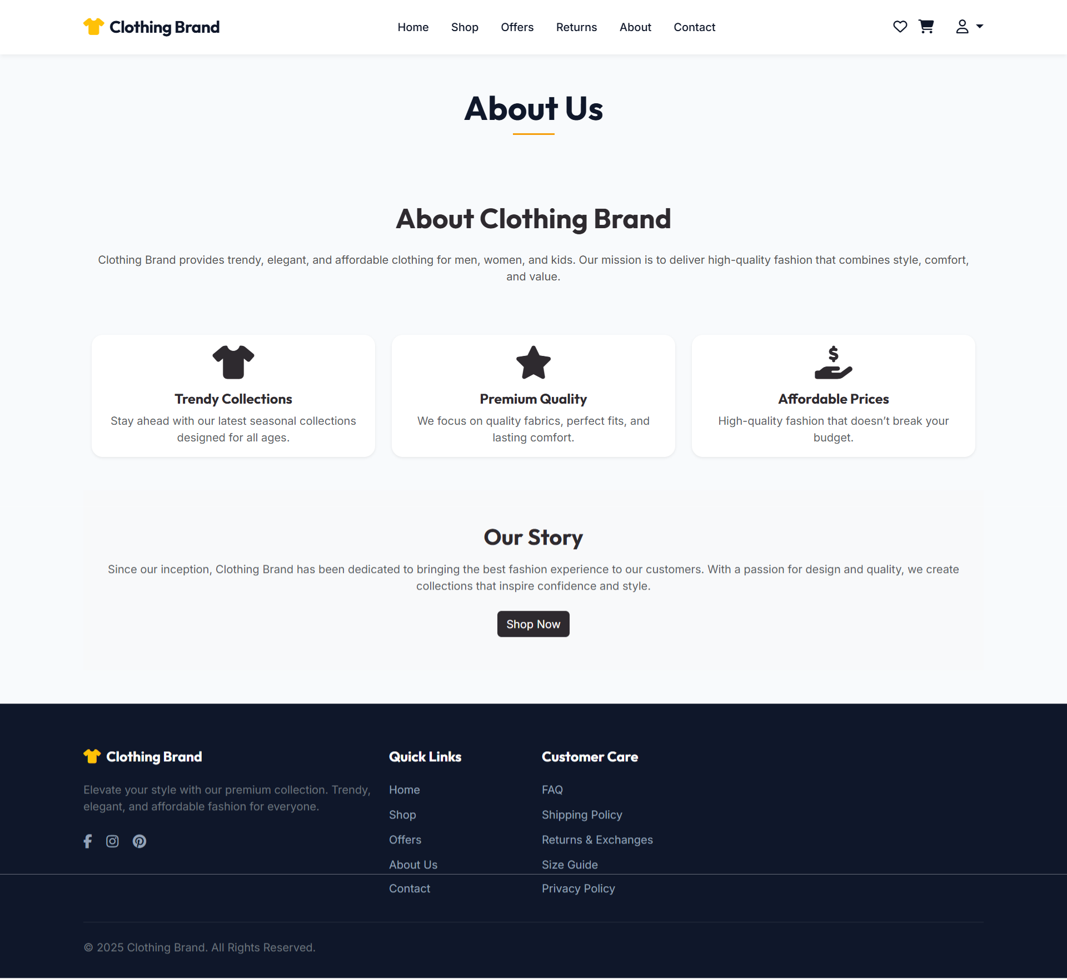


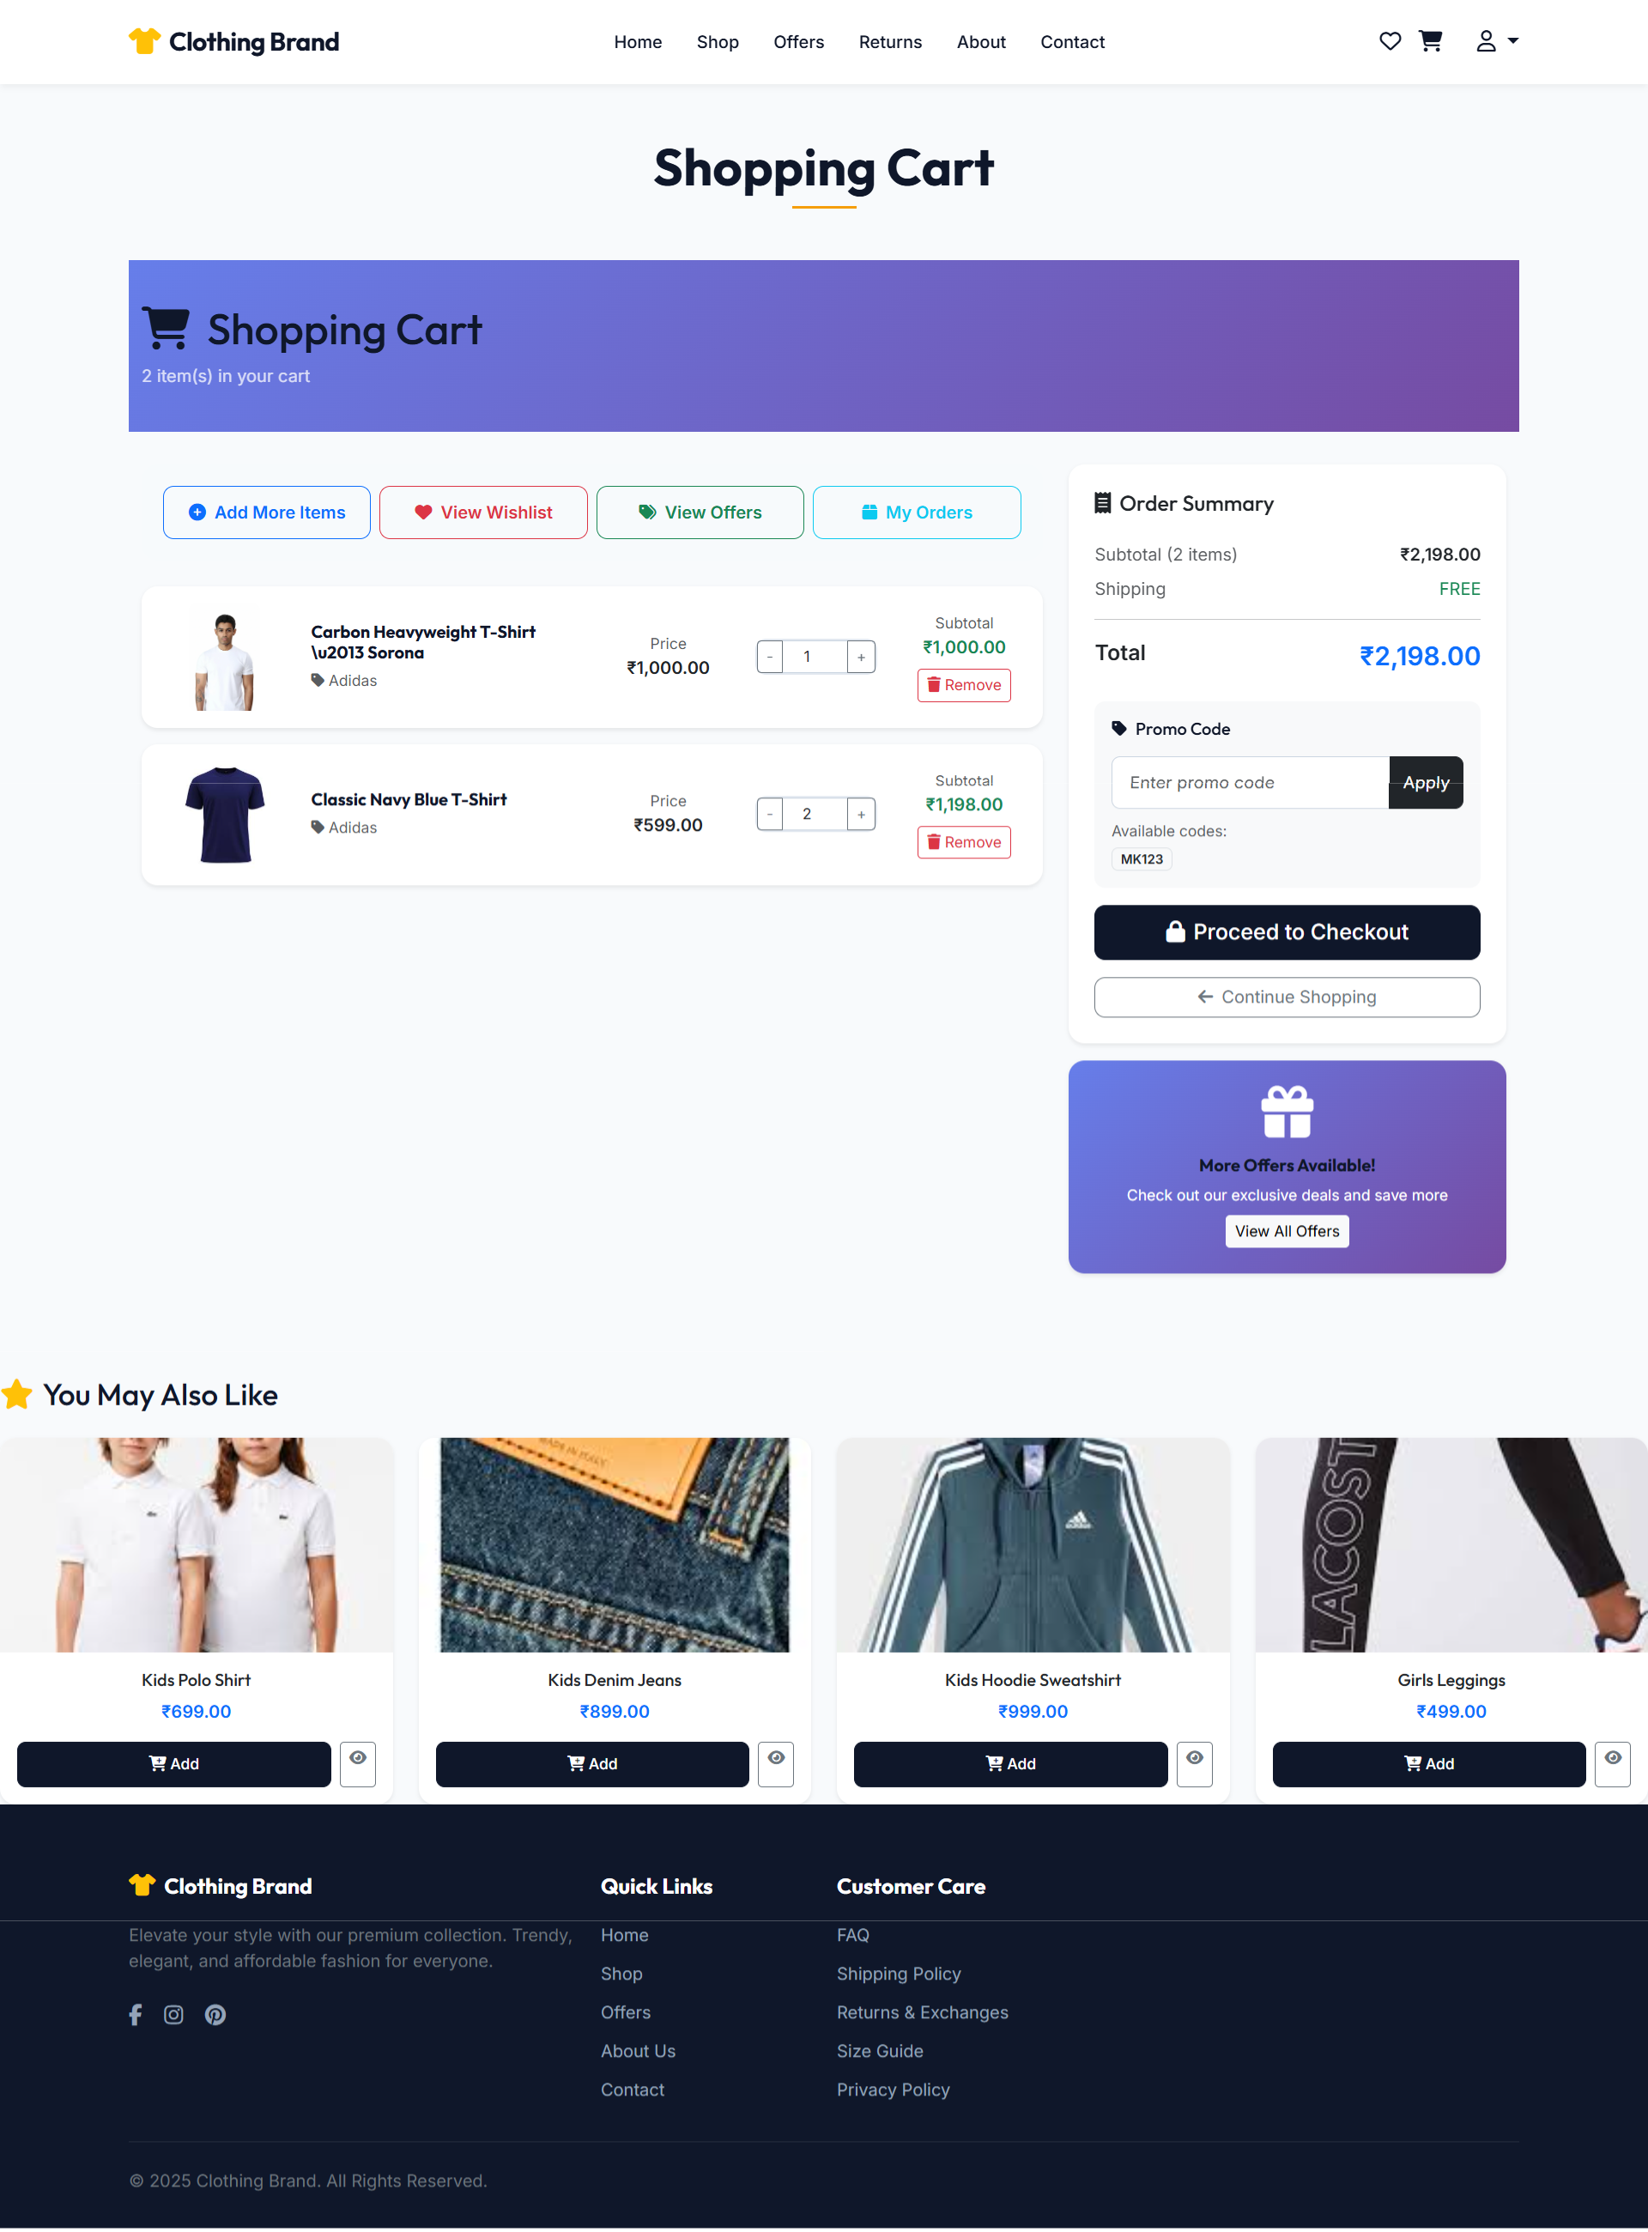
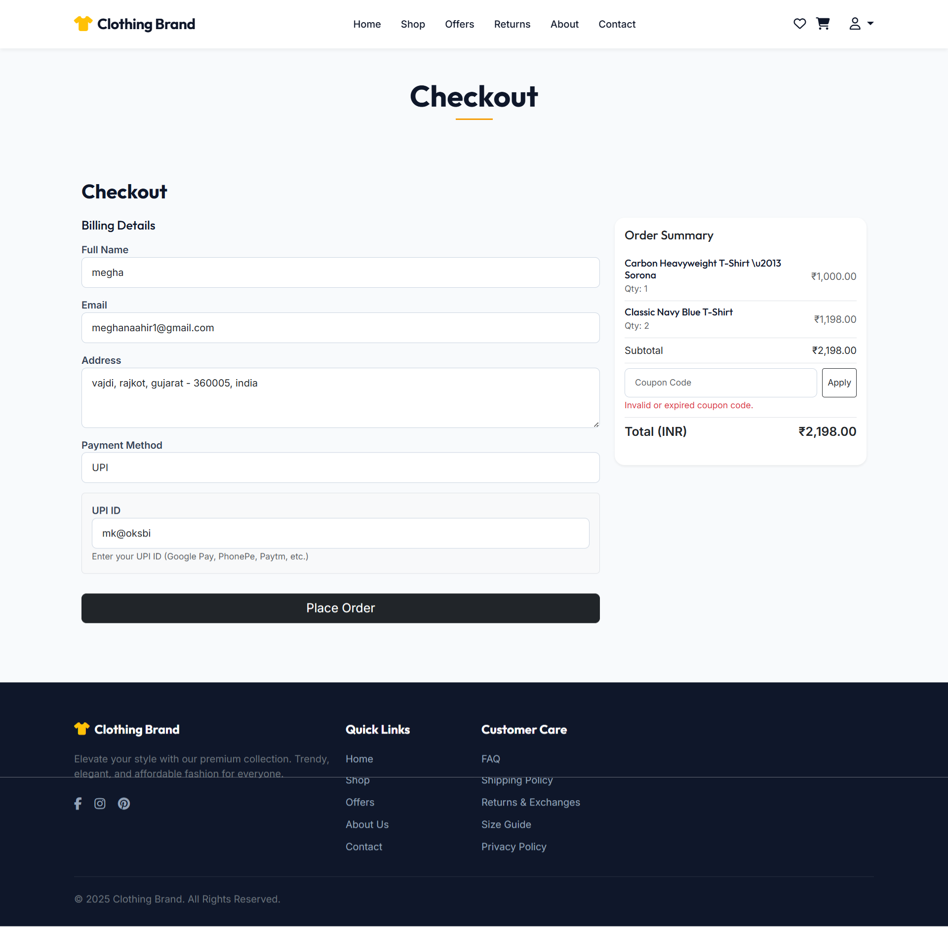
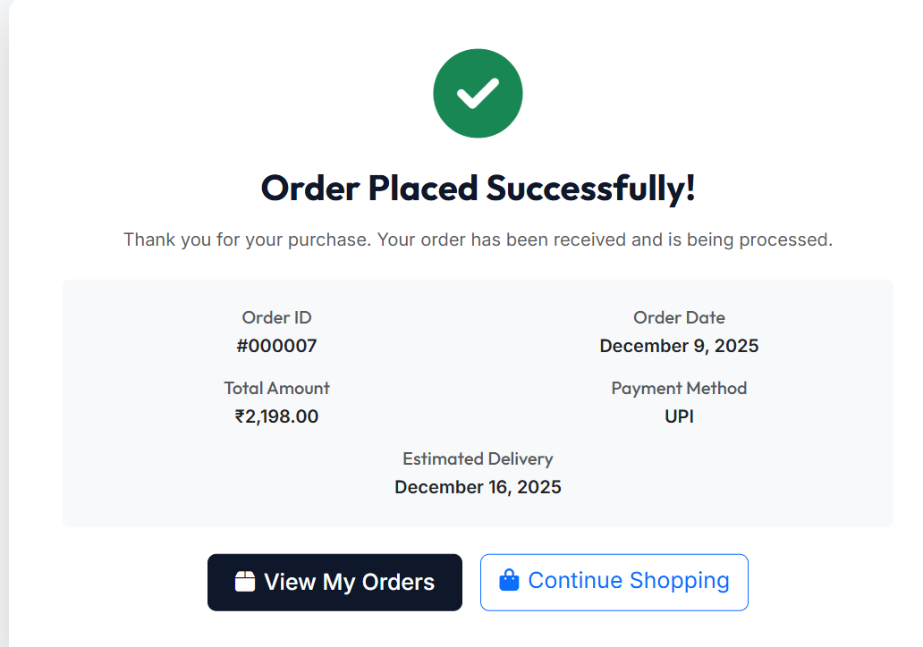
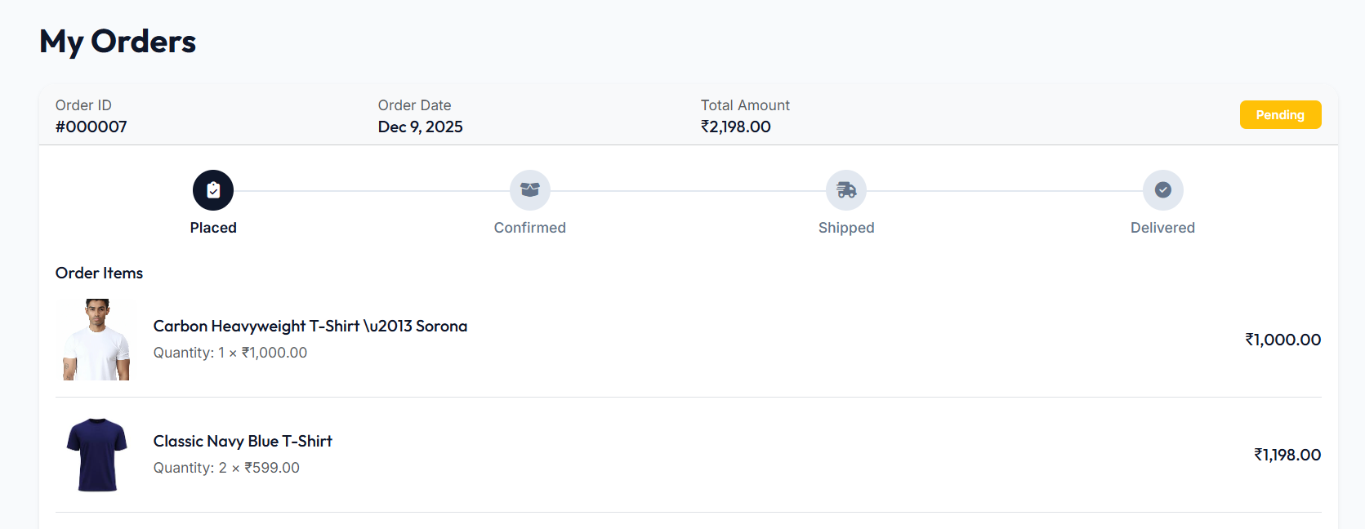

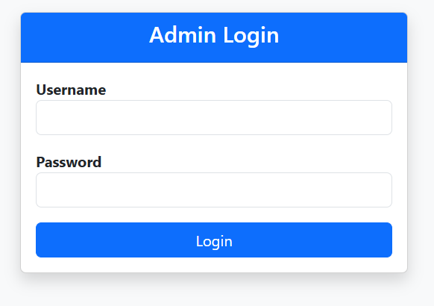
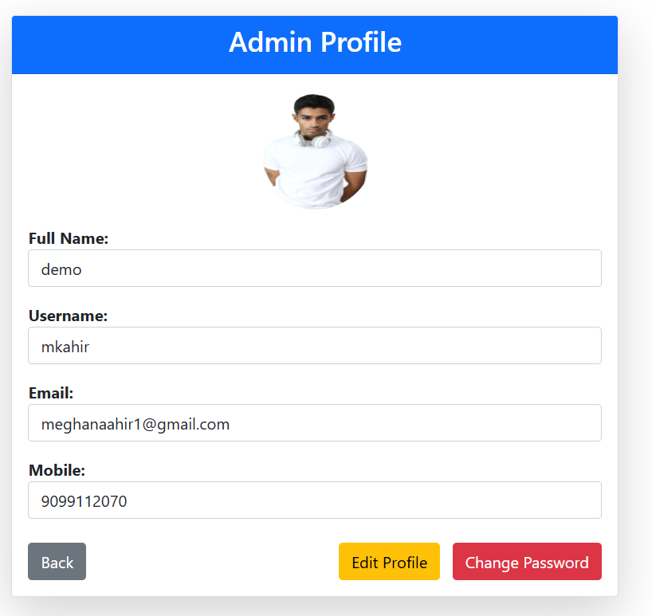
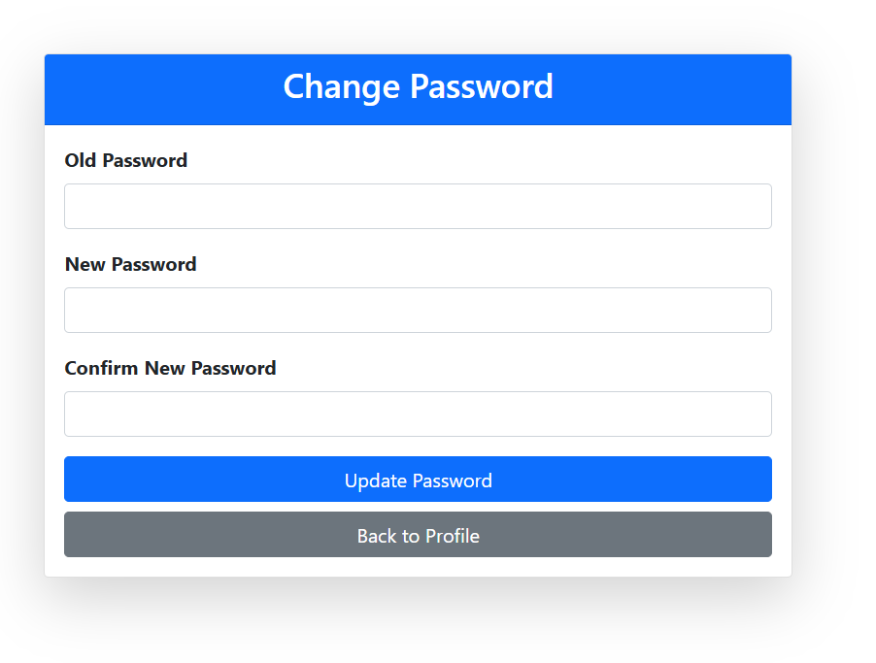
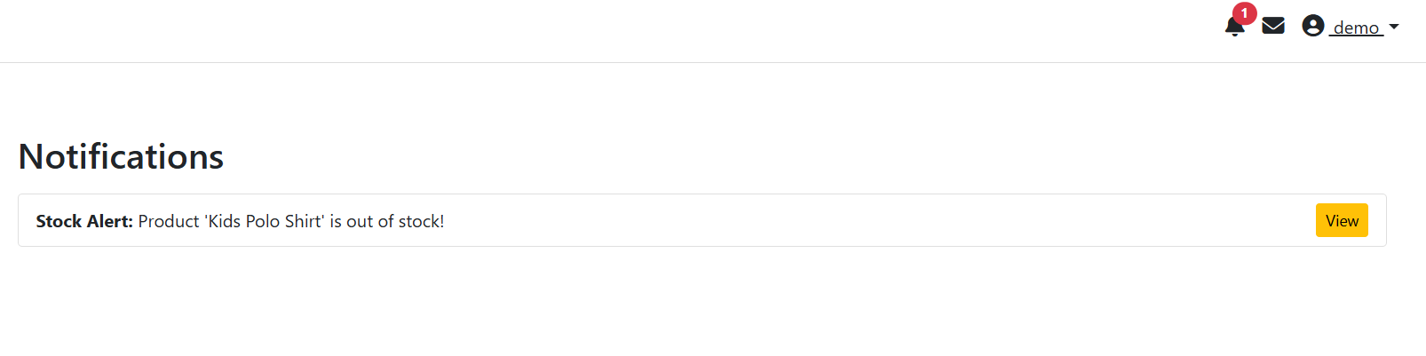
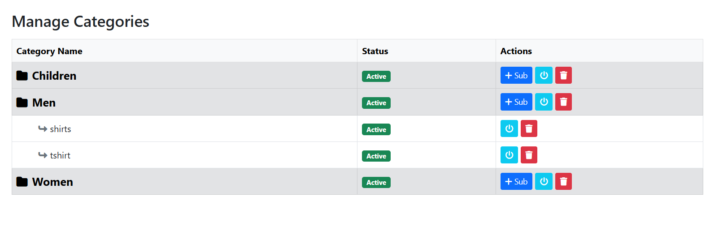
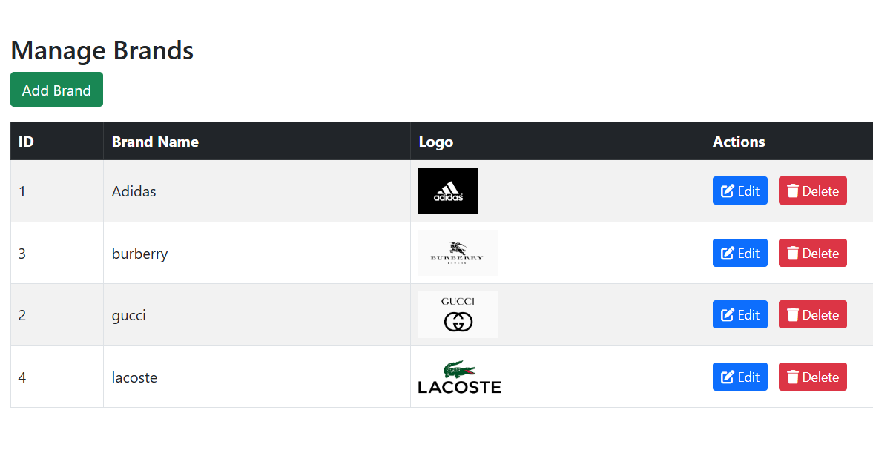
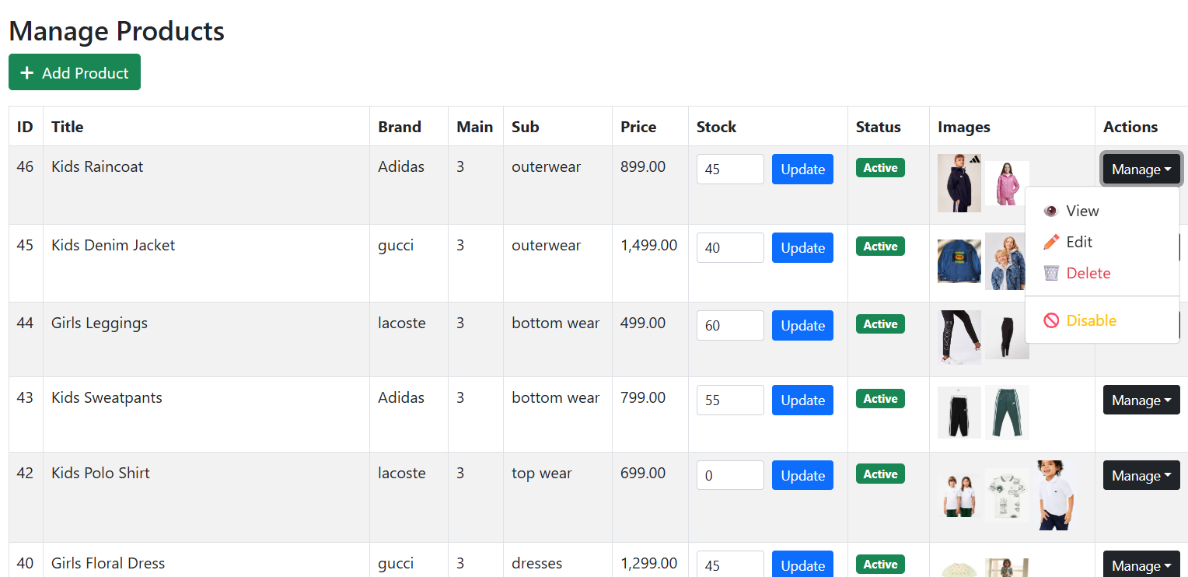
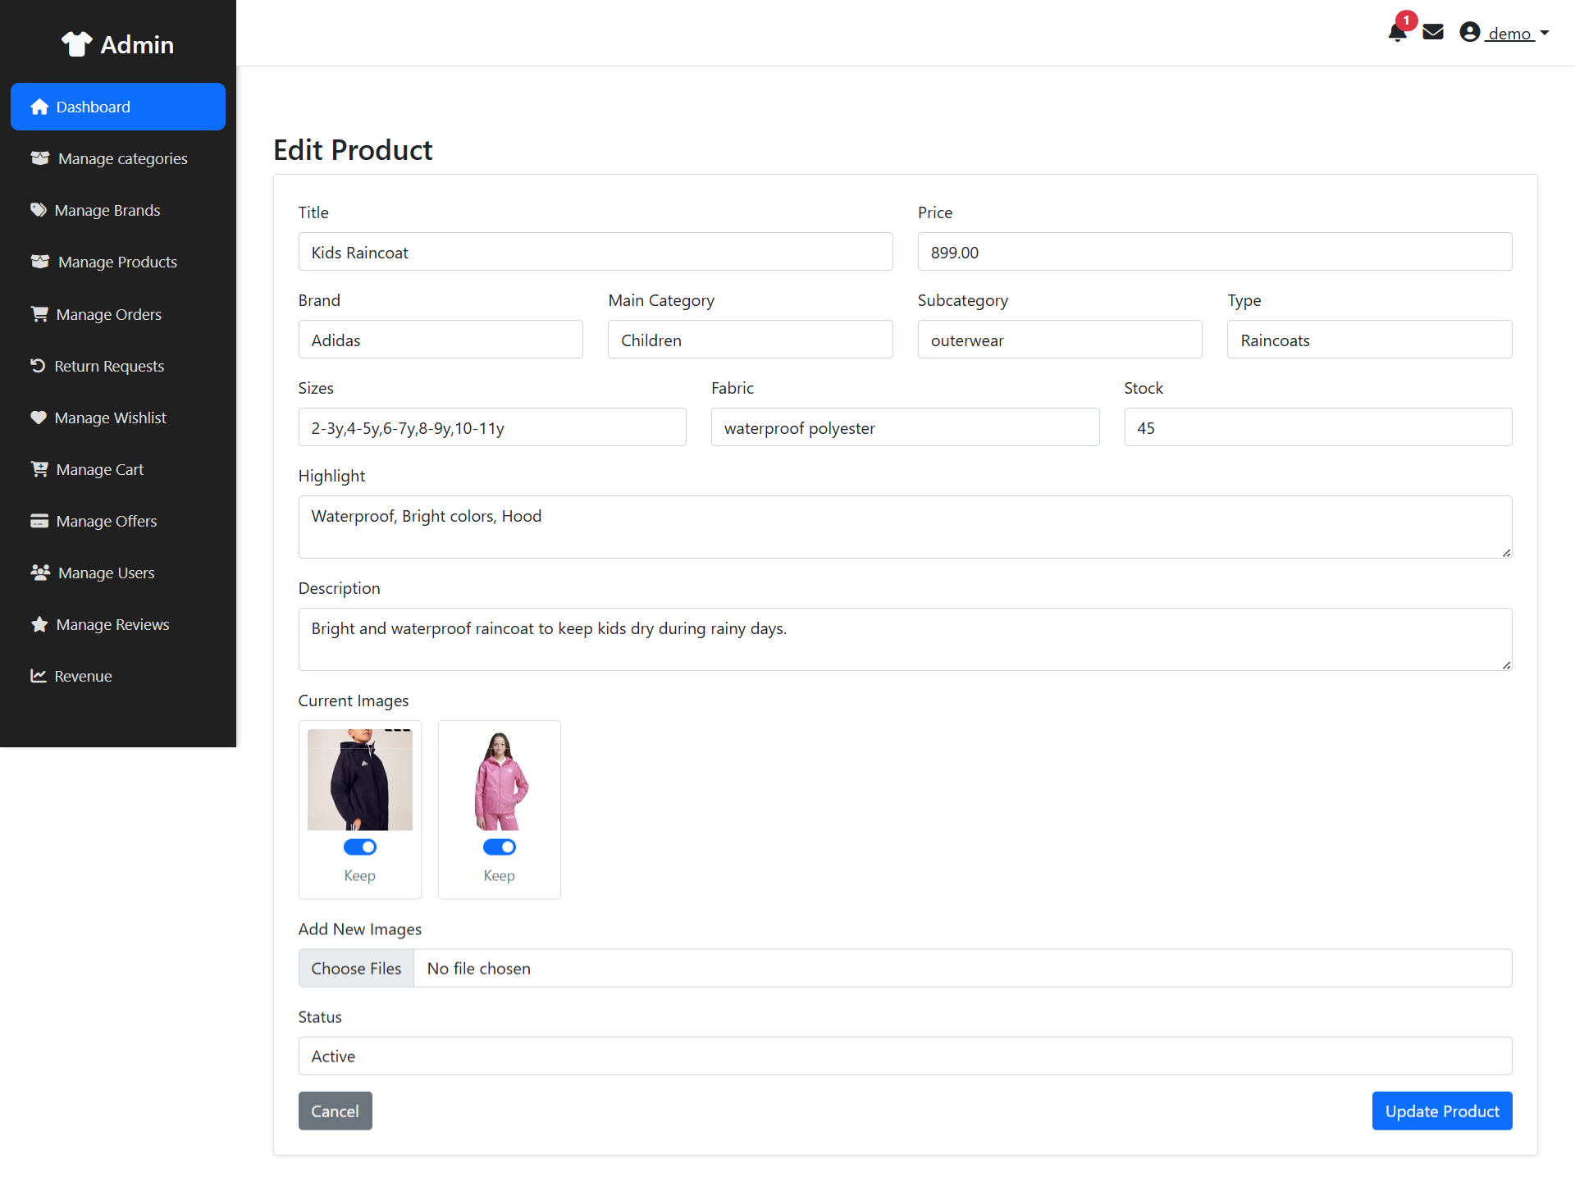
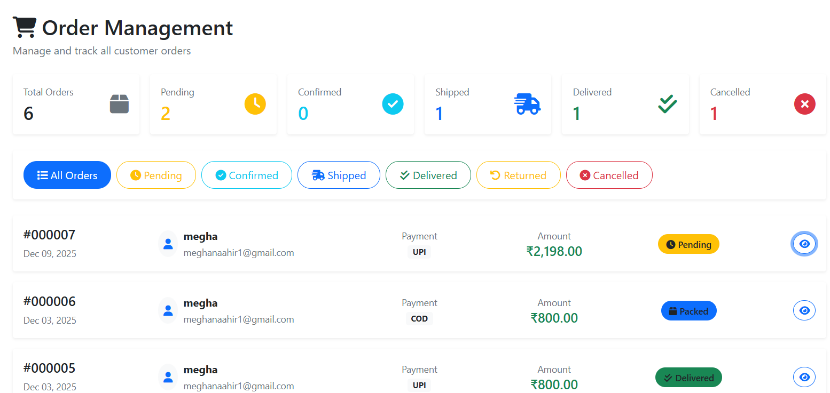
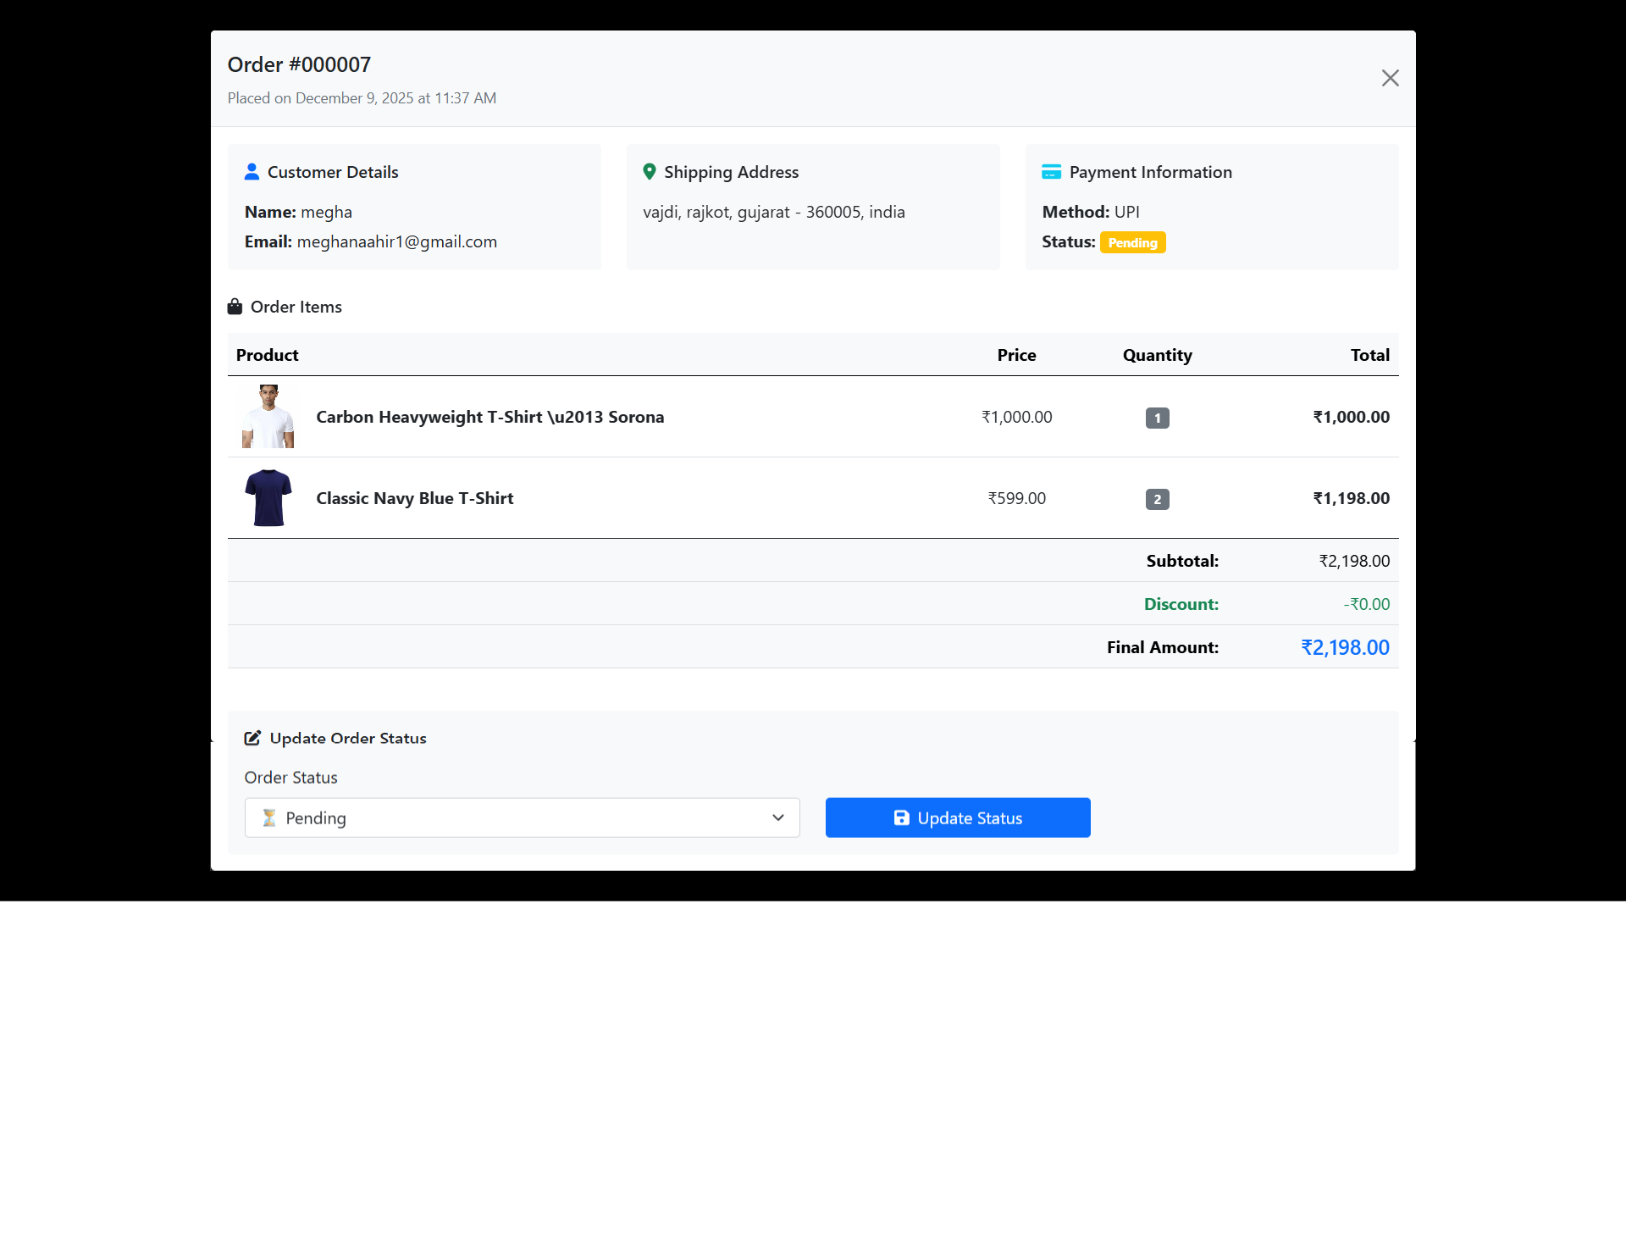
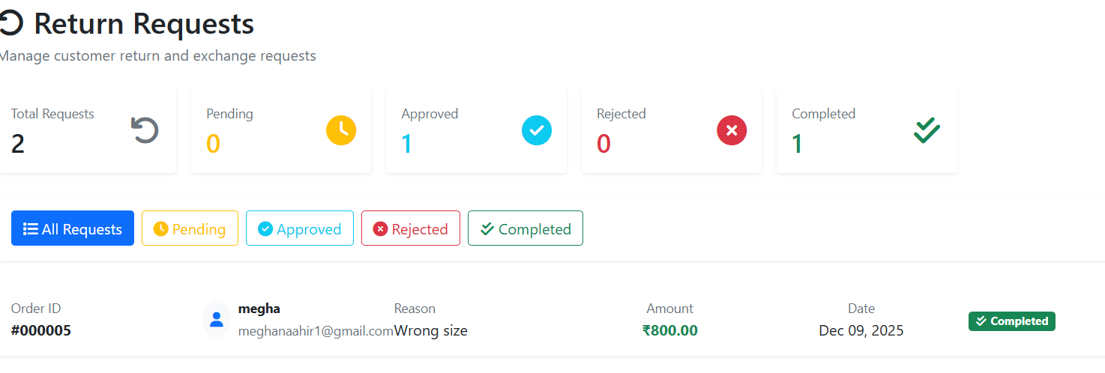
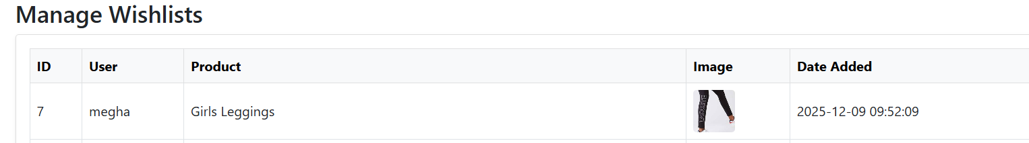
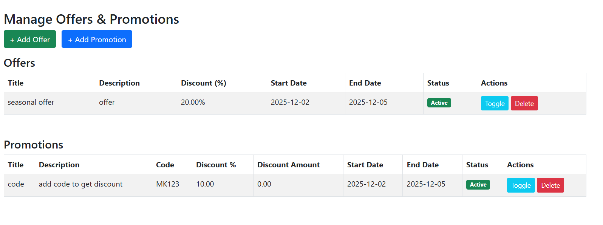
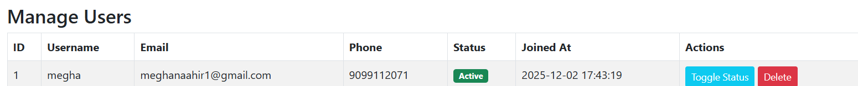
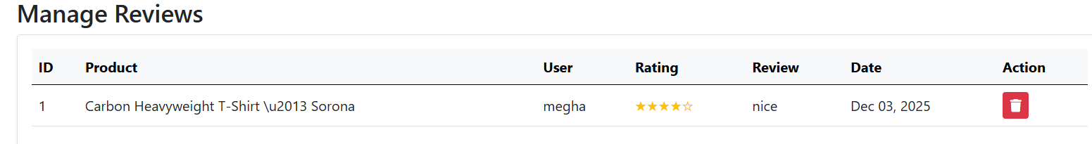
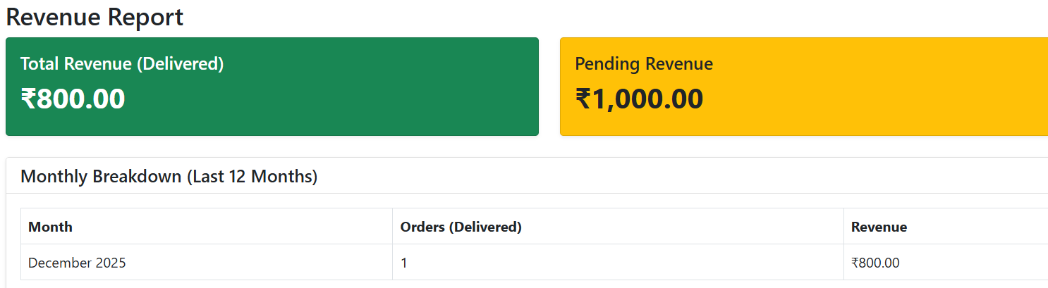

CHAPTER 9 – LIMITATION & FUTURE ENHANCEMENT
[Write content here]

CHAPTER 10 – CONCLUSION AND DISCUSSION
[Write content here]

